Week 1 Lab

Student Details:
Student Name: Manjot Singh
Student Id:991808820
Program: Computer Systems Technician – Information Technology Infrastructure and Services

Exercise 1
Step 1:
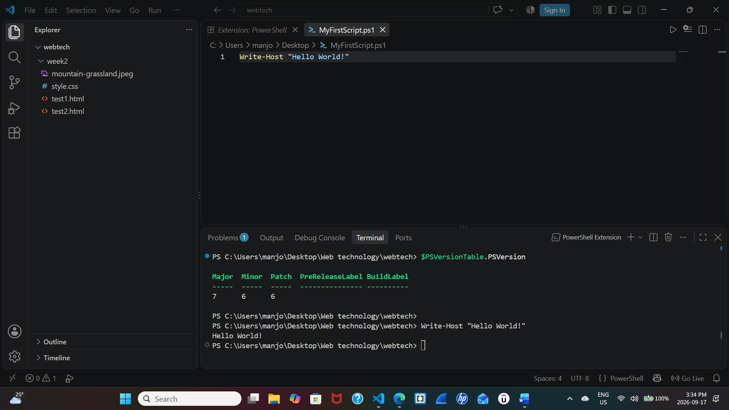
Paste the full screenshot here. Briefly explain the output.
The power shell command Write-Host "Hello World!" the output as text “Hello World!” in the PowerShell terminal. As we are using extension our VS code. Moreover the power shell version is 7 When the command is selected and executed using F8 in VS Code, the output appears in the terminal which is near bottom. This confirms that the PowerShell script is running successfully in our VS Code.

Step 2:
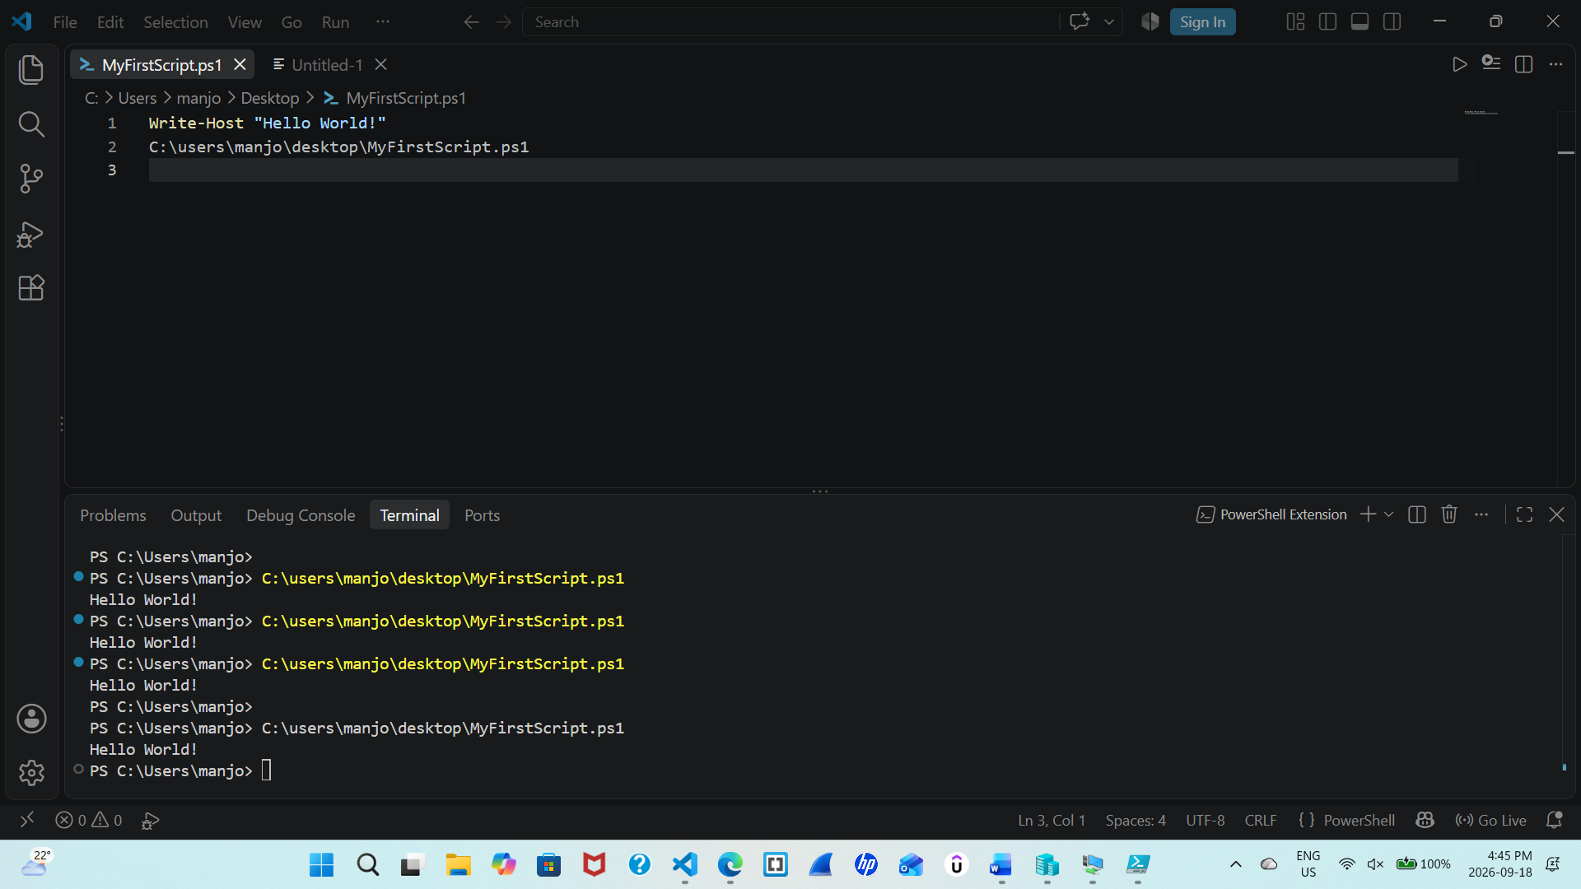
Paste the full screenshot here. Briefly explain what happens when script runs inside the terminal?
This step should be done before saving the document and the command should be in terminal not the area of vs code other wise it will repeat itself continuously.
The result is that yes we can open the script via powershell and run any script.
And show its result via path
Step 3: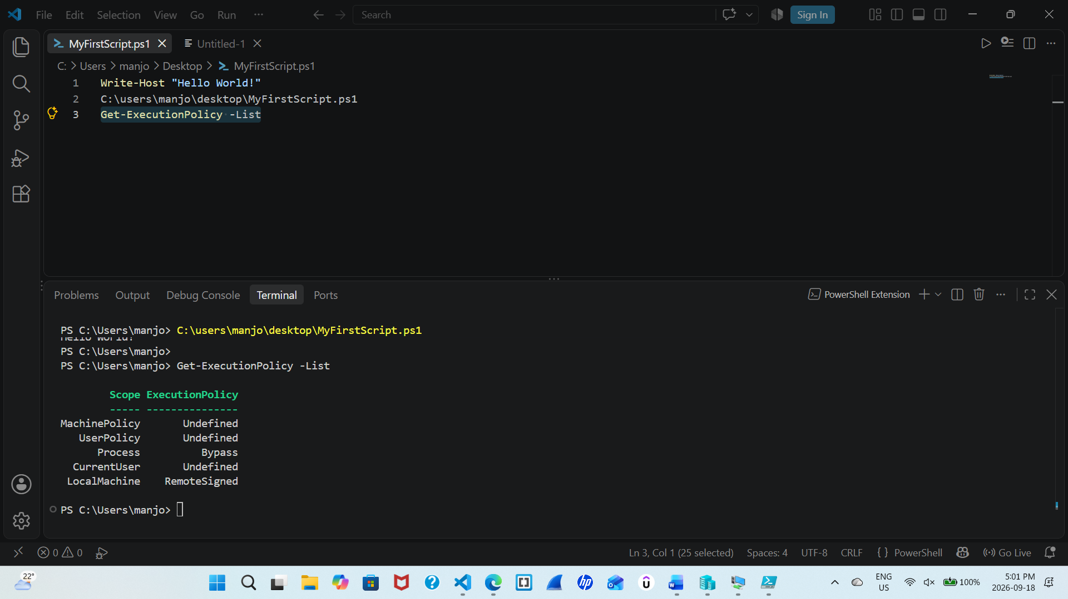
Paste the full screenshot here. Briefly explain the output.
This command Get-ExecutionPolicy -list show me the policy of machine, user, process, current user , local machine and scope on my device. These policies control how the power shell scripts will be executed and under which conditions it will be exceuted.
Step 4:

Command= Get-Date (It shows full date and time)
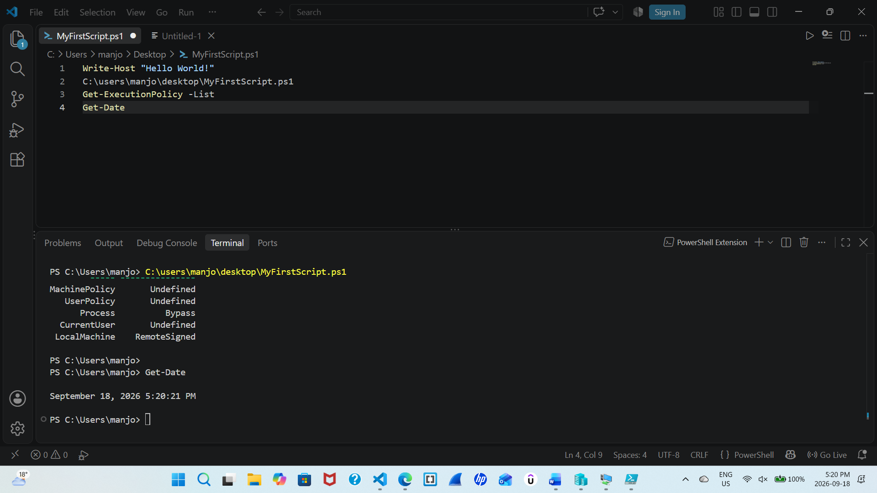
Command= Get-Date -format hh\:mm\:ss (This shows hour, minute, second only)
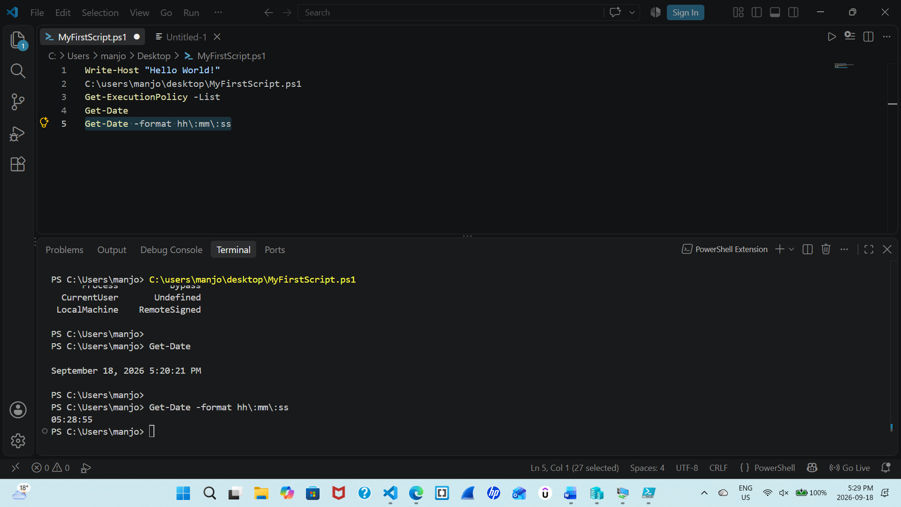

Paste the full screenshot here. What is the difference between both the commands?
Get-Date (It shows full date and time)
Get-Date -format hh\:mm\:ss (This shows hour, minute, second only)
Both show time but in different format and what we demand from specific command.

Step 5:
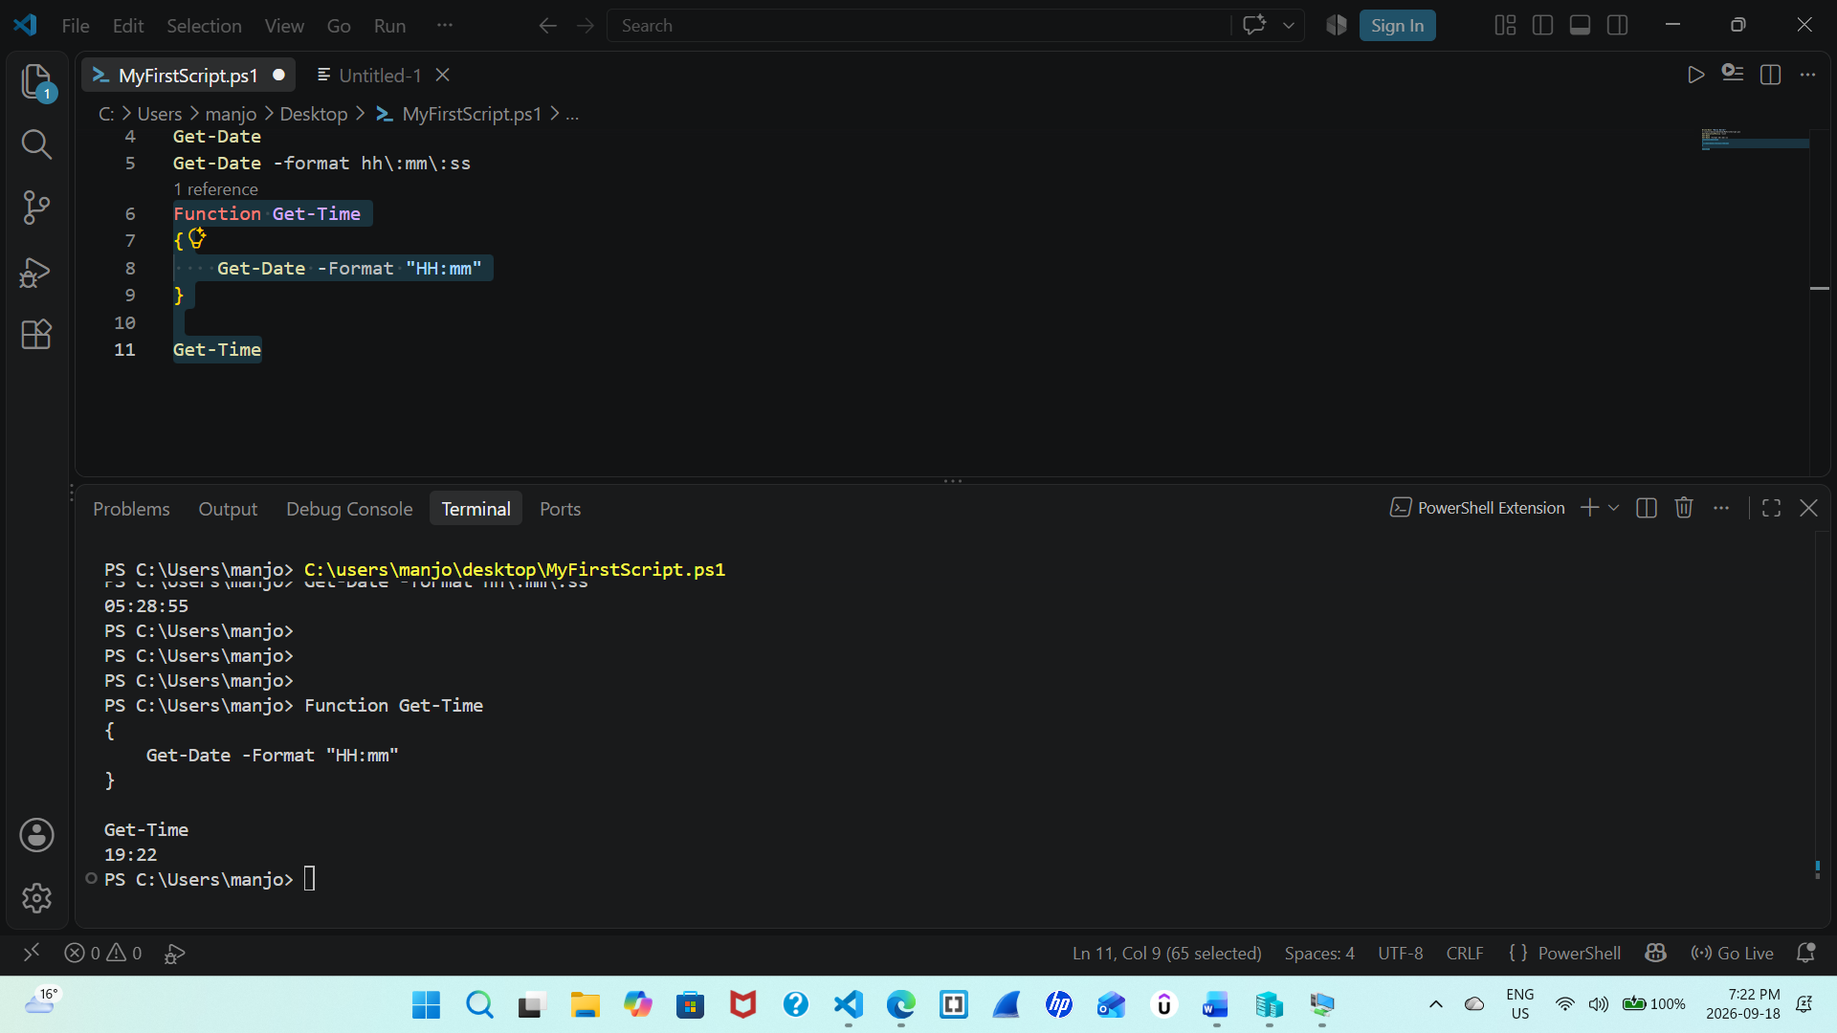
This demonstrate that we can perform specific task using script and like difference in commands is that in one hour,minuteand sec are visible whereas in one on standard day date and time. In other words it uses the HH parameter so only the current hour and minute are visible. Whereas you run Get-Time, the function executes and prints the current time in your PowerShell window.
Command =
Function Get-Time
{
Get-Date -Format "HH:mm"
}

Get-Time

Paste the full screenshot here.

Step 6:
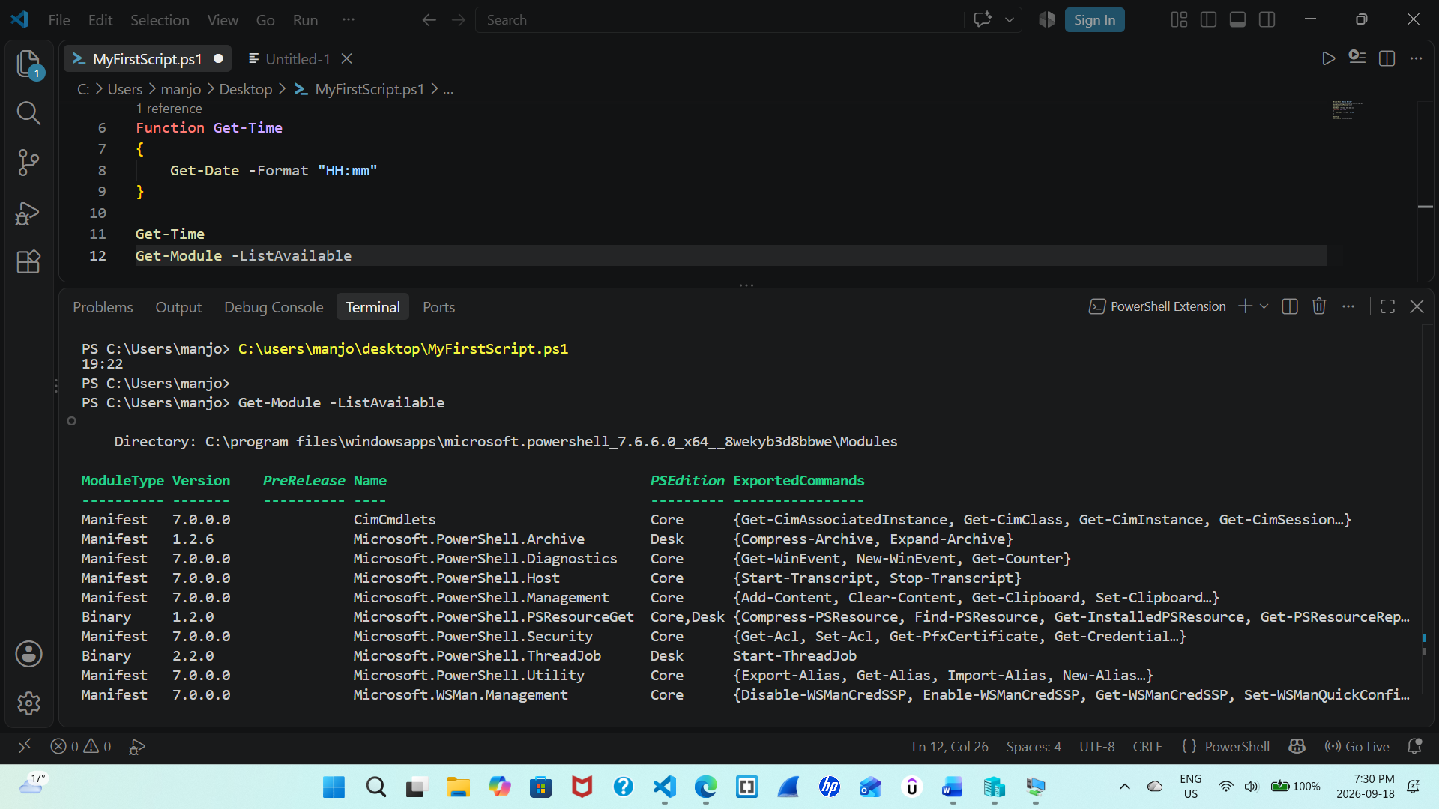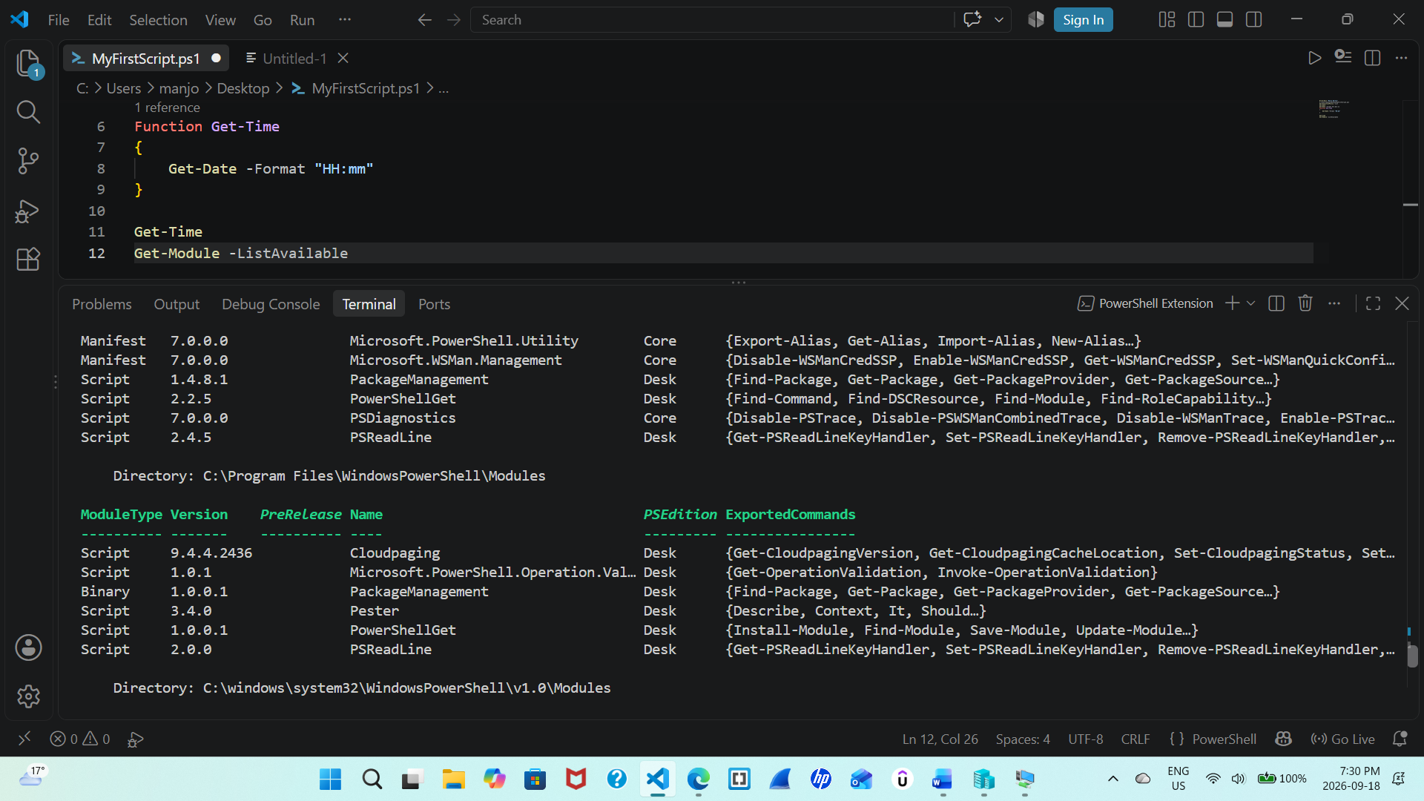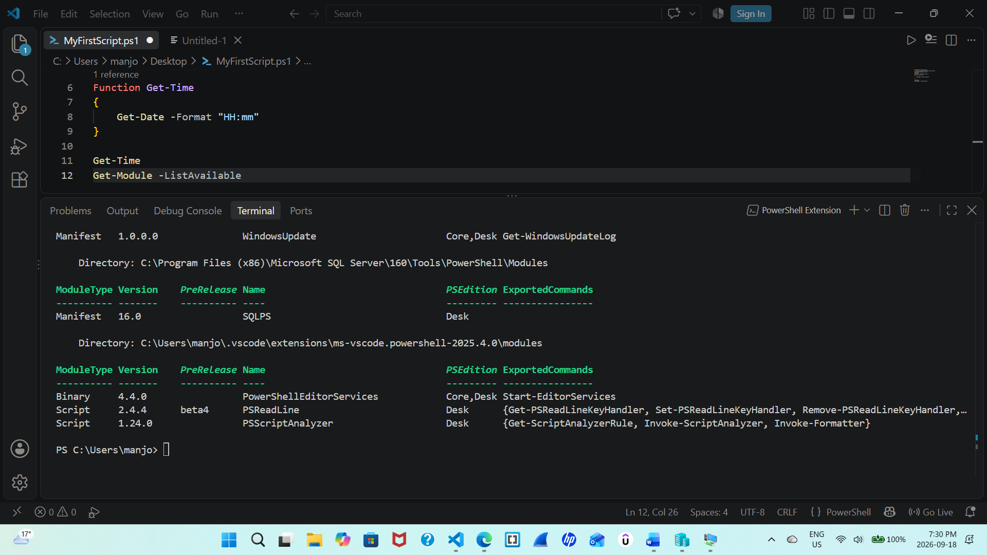Paste the full screenshot here.
This command dispalys all the powershell modues that are available and also additional module which can be used by powershell. It shows there current version and types which may vary in powershell the way it is installed.
Step 7:
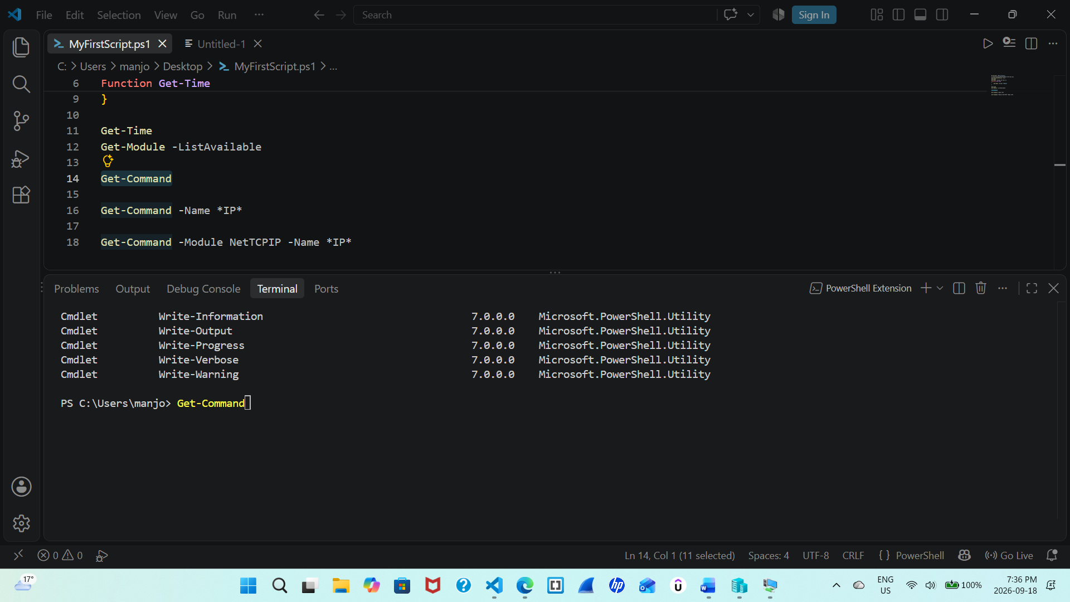
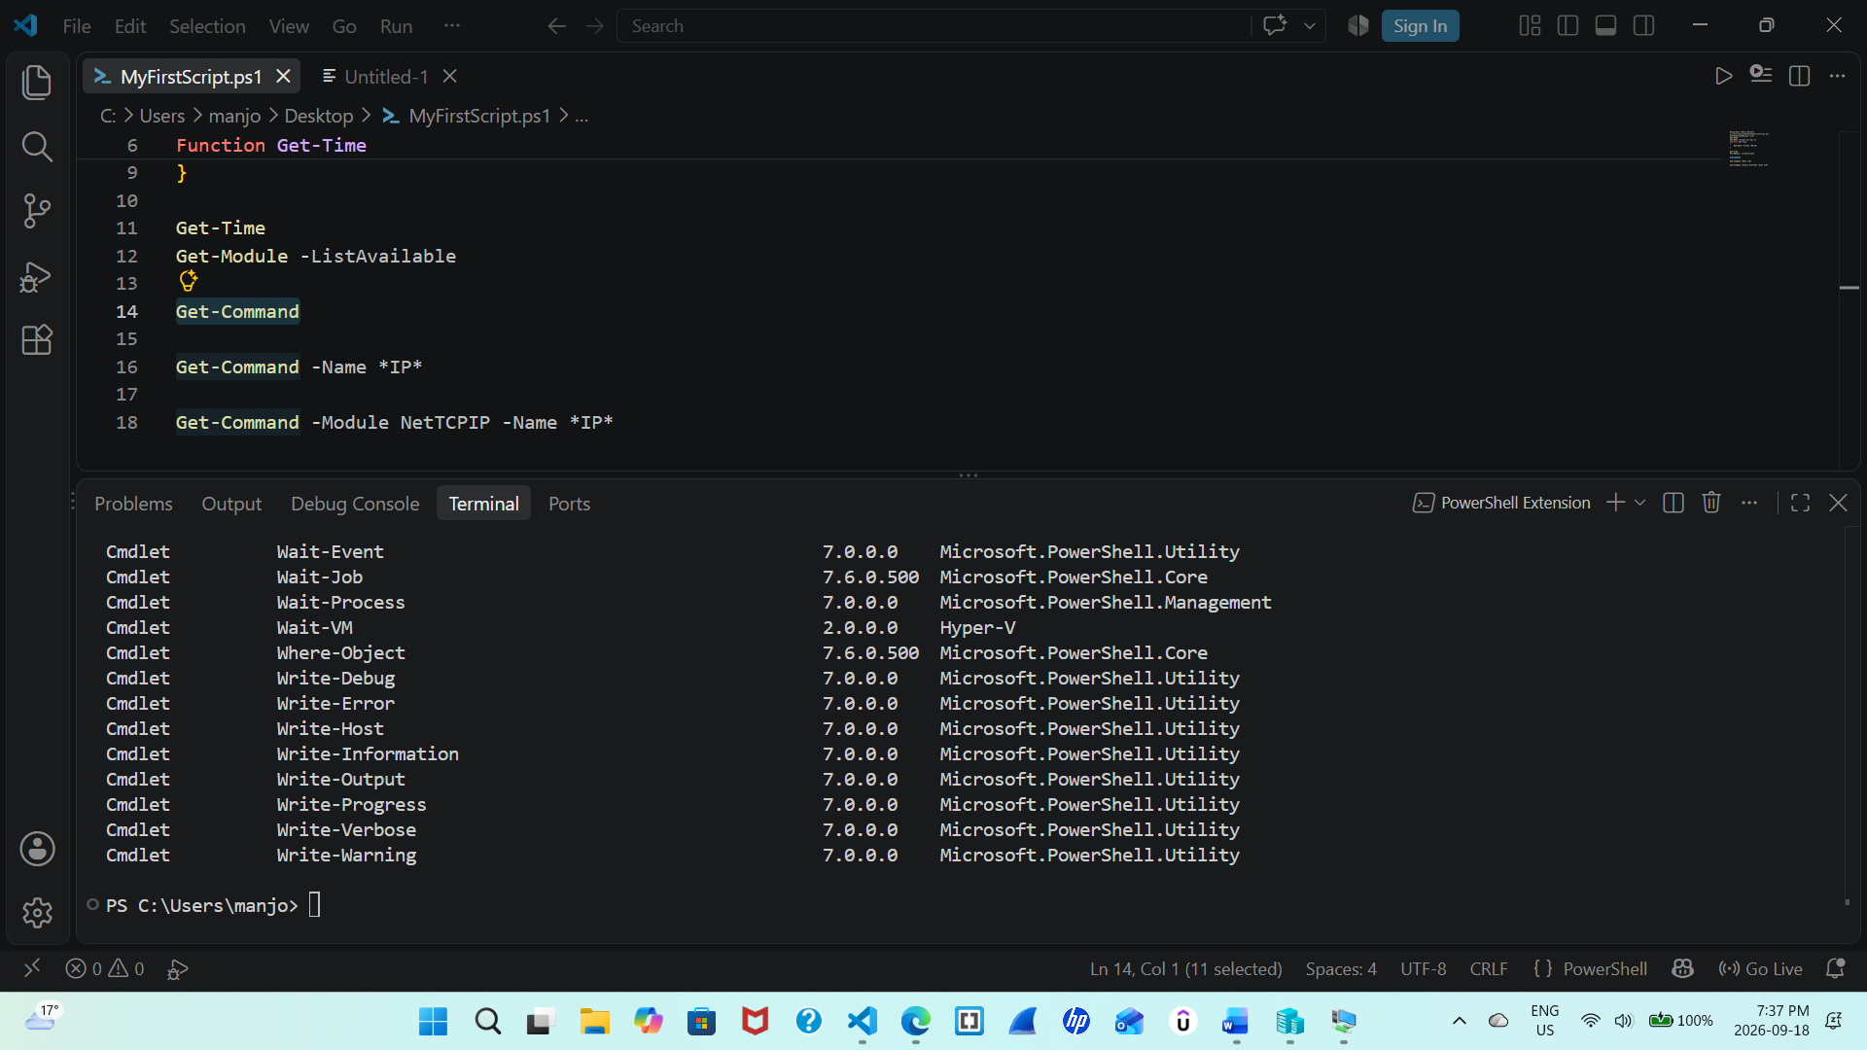
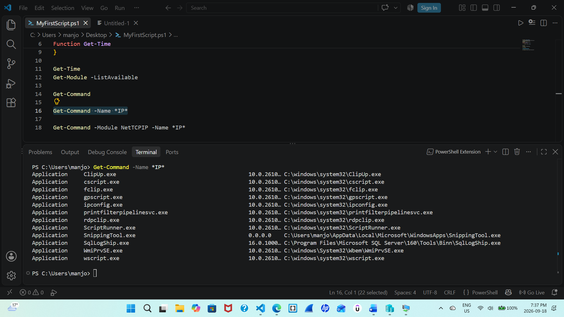
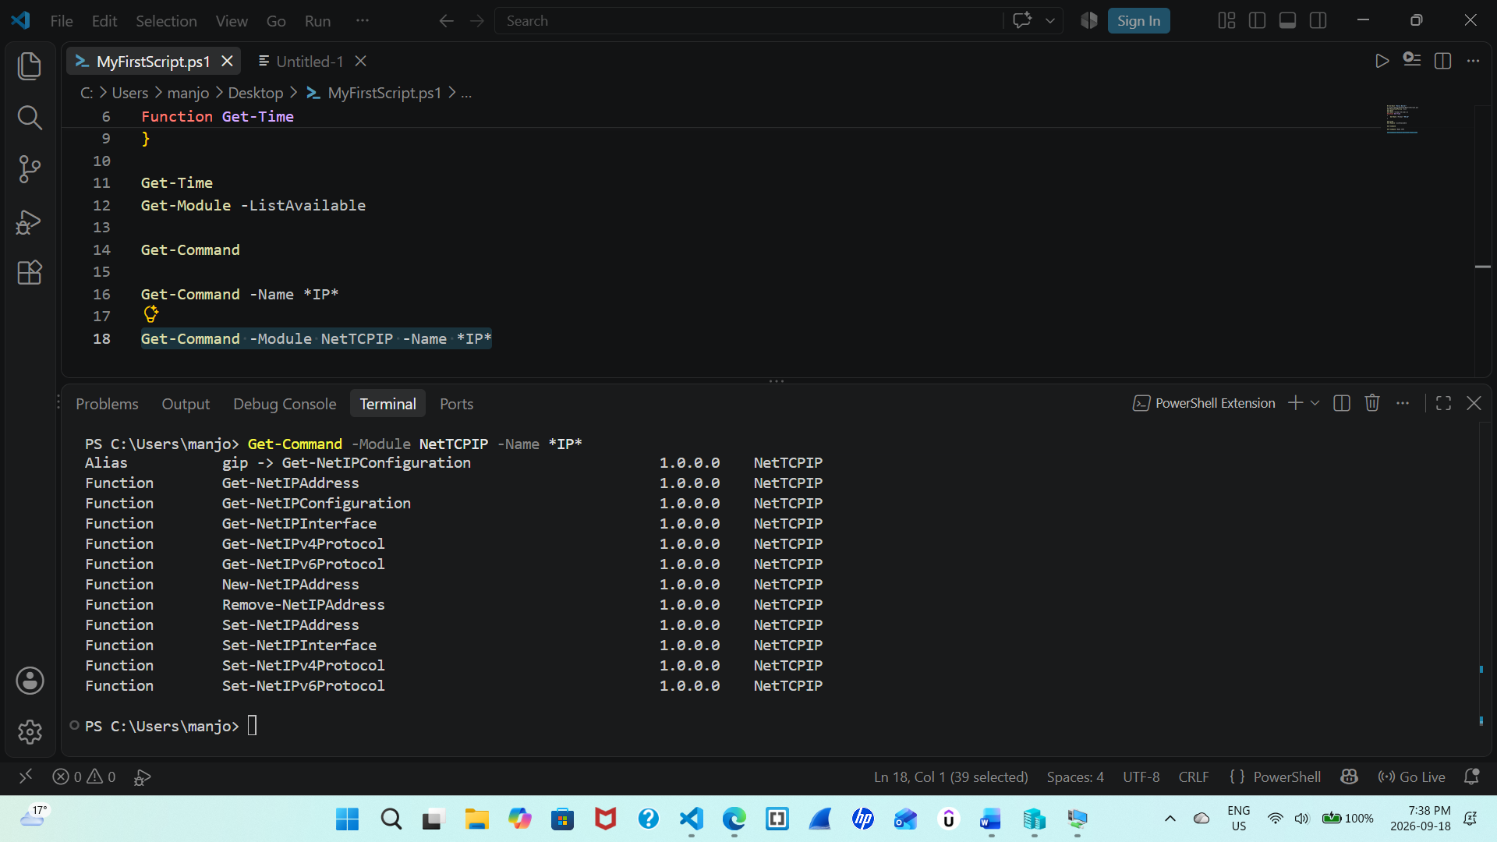
Paste the full screenshot here. Describe the difference between both commands.
Get-Command

Get-Command -Name *IP*
This searches the commands who contain word ip irrespective of any module without any restriction.

Get-Command -Module NetTCPIP -Name *IP*
This command search the word in particular module and is restricted to NetTCPIP. There fore it searches only in a limited module.

Step 8:
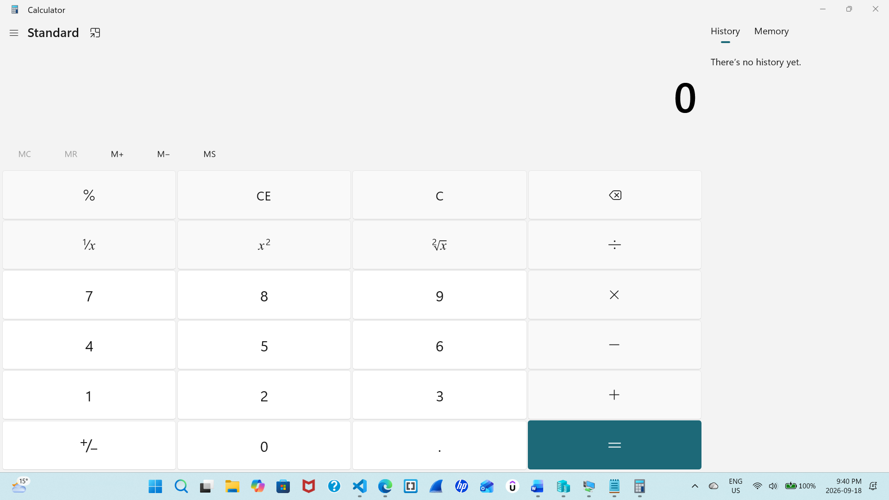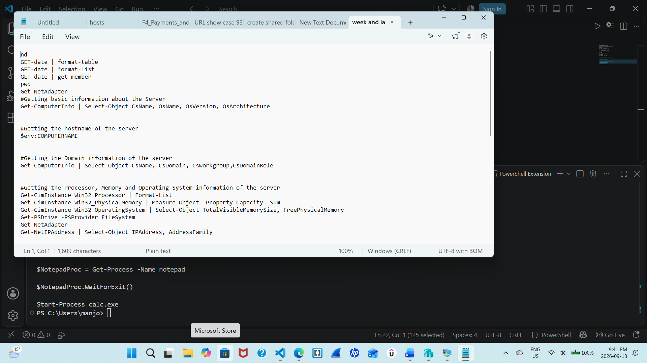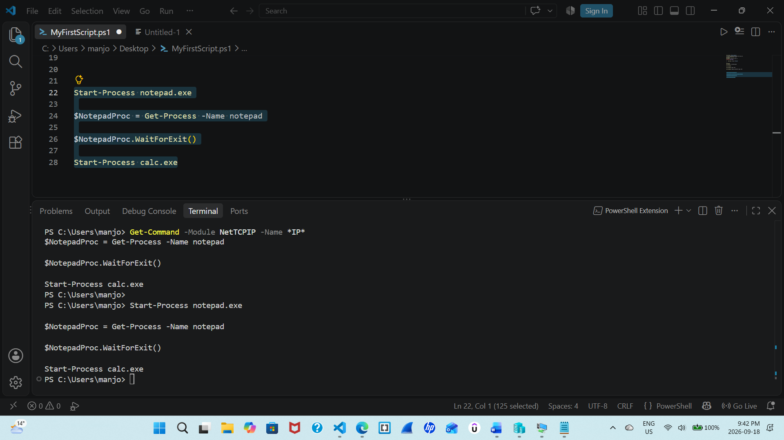
This command purpose is to show how the shell can operate different apps like first it notepad then waited to open the calculator on full screen the Notepad process and stores it in the $NotepadProc variable. The WaitForExit() till note pad is closed and opened calculator.
This show we can open and use apps via power shell.
Paste the full screenshot here. Describe the purpose of the given script.
Step 9:
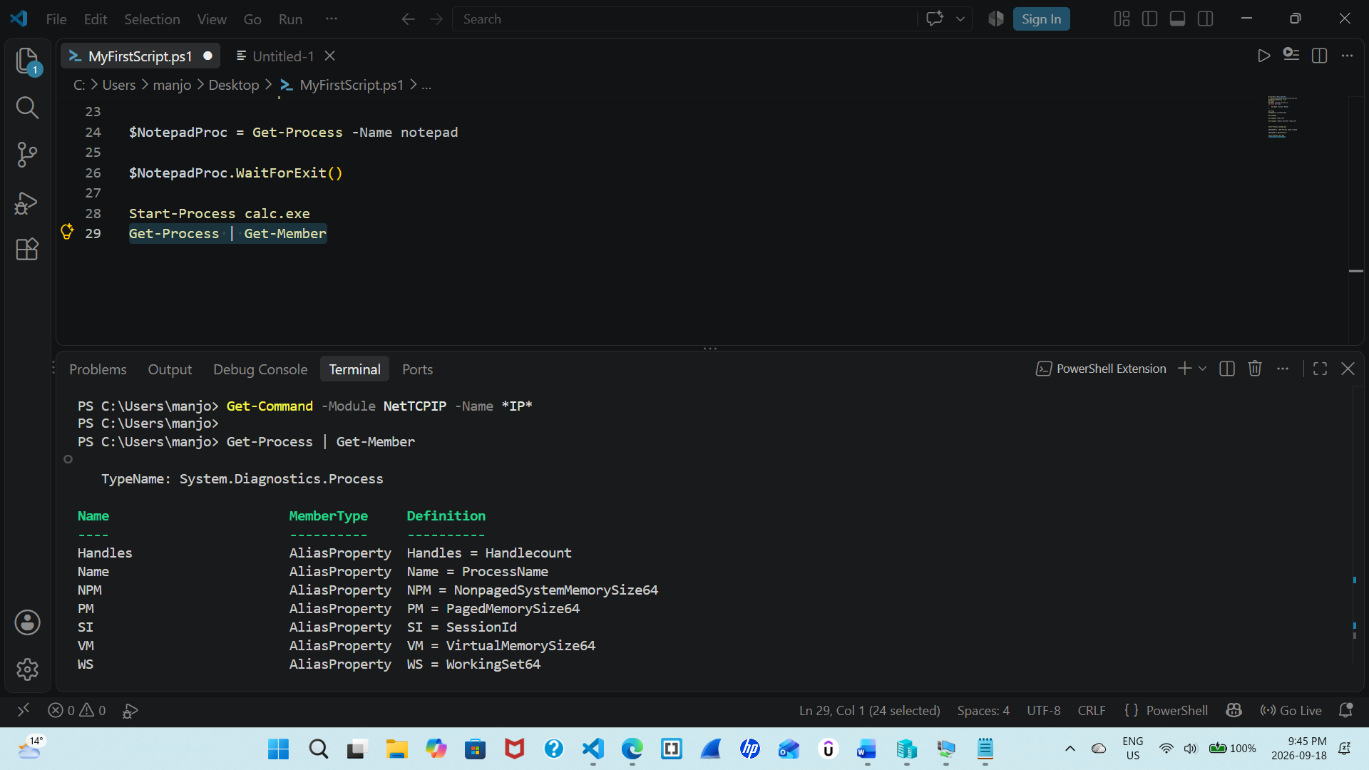
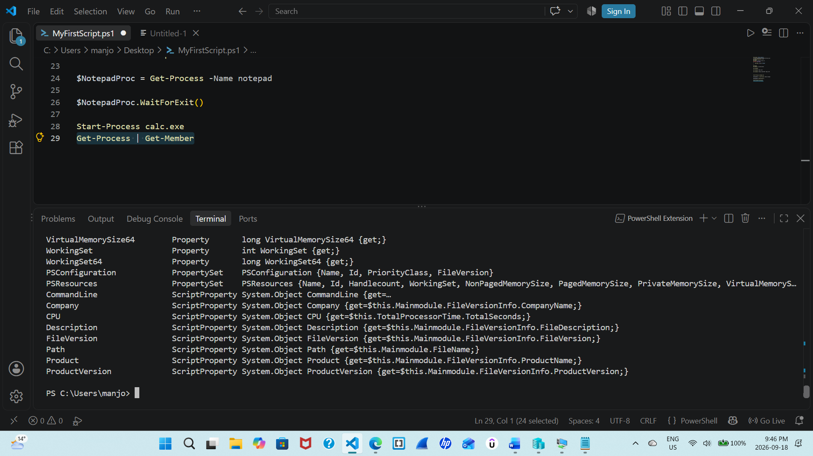
Get-Member displays the properties and methods available for those process objects the command shows. This command(get-process) mainly shows the current processes that are running on the device.

Paste the full screenshot here.

Exercise 2
Note: Starting few lines of the output is enough if the output is spanning to multiple pages
Step 1 Display basic help information about a cmdlet
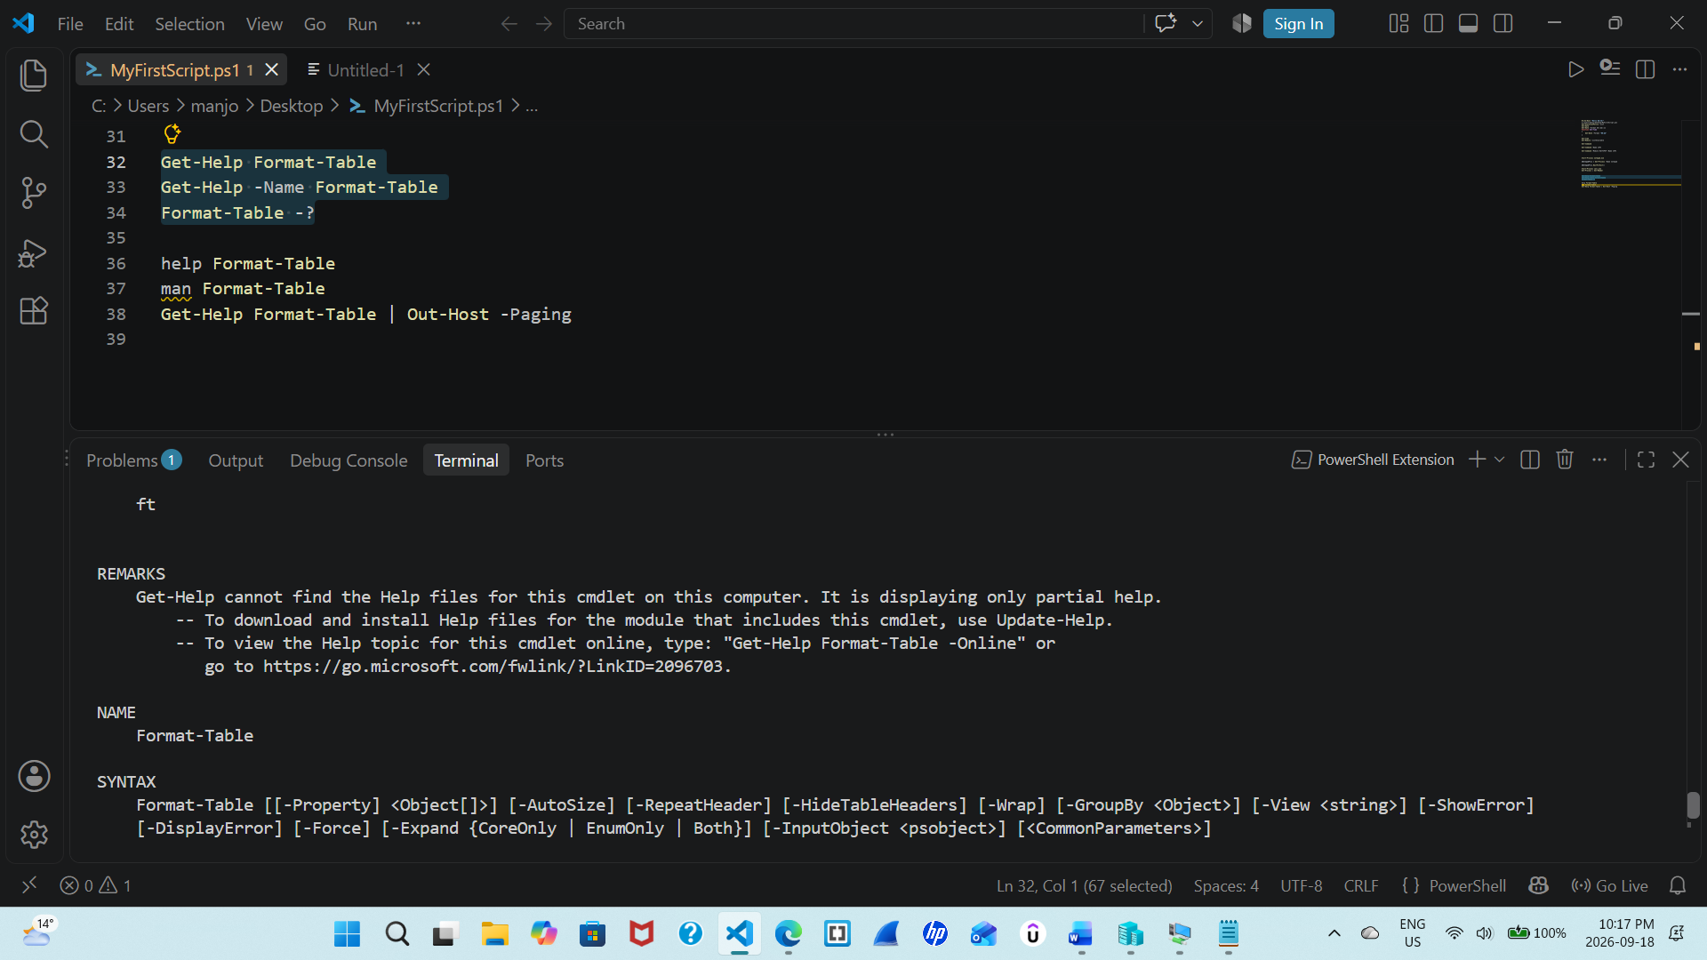
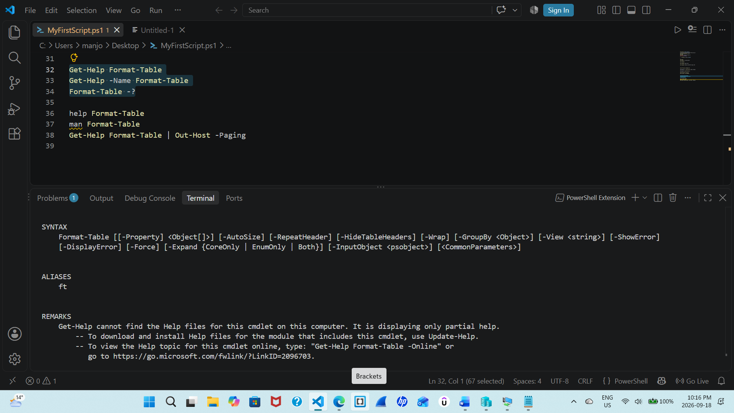
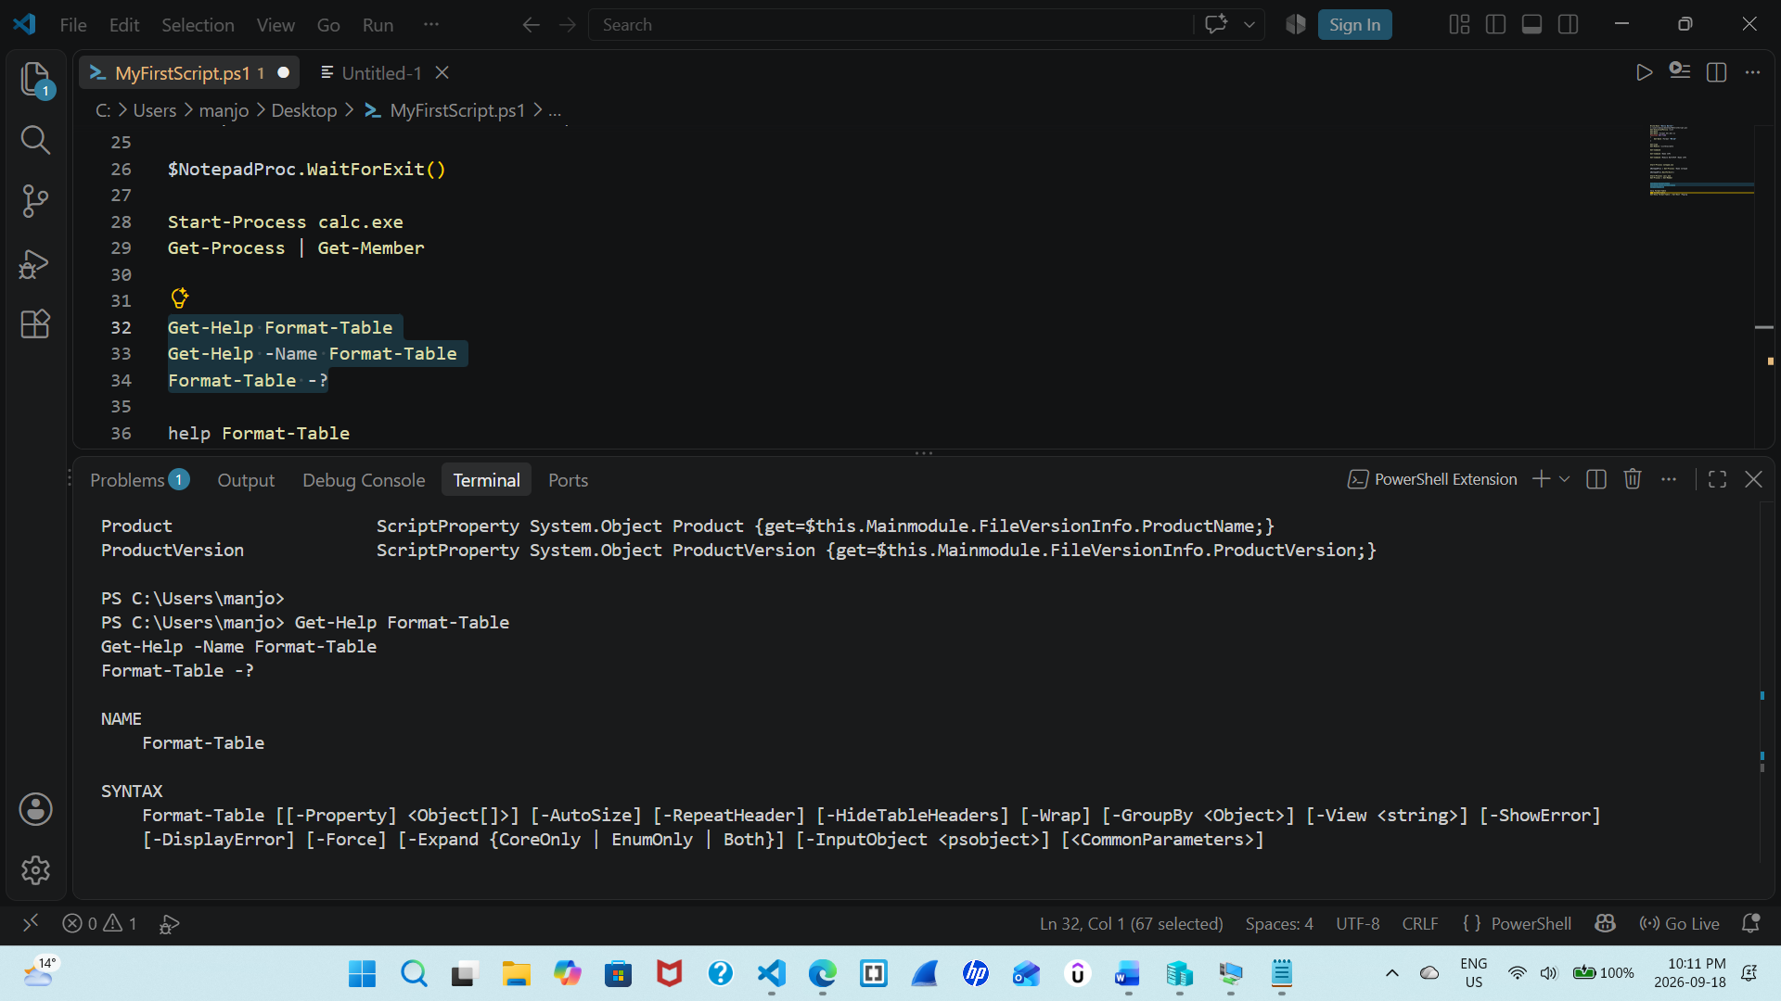
These commands help us to display basic help information for the Format-Table cmdlet.
Get-Help provide us with the information about the cmdlet. while Format-Table -? also displays its help information. The output explains the purpose, syntax, parameters, and usage of the cmdlet.
Paste the full screenshot here.

Step 2 Display basic information one page at a time
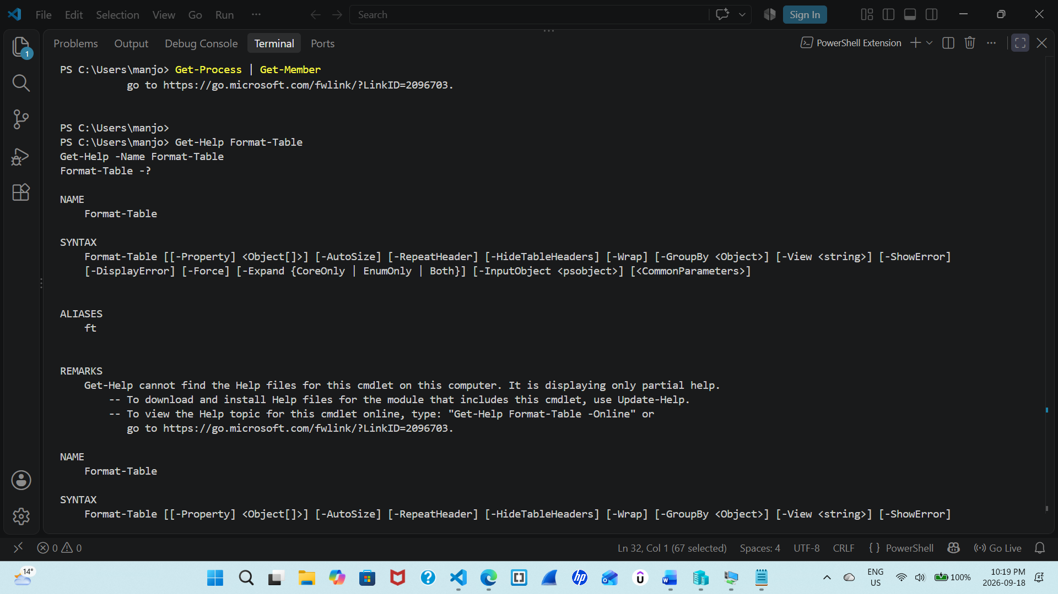 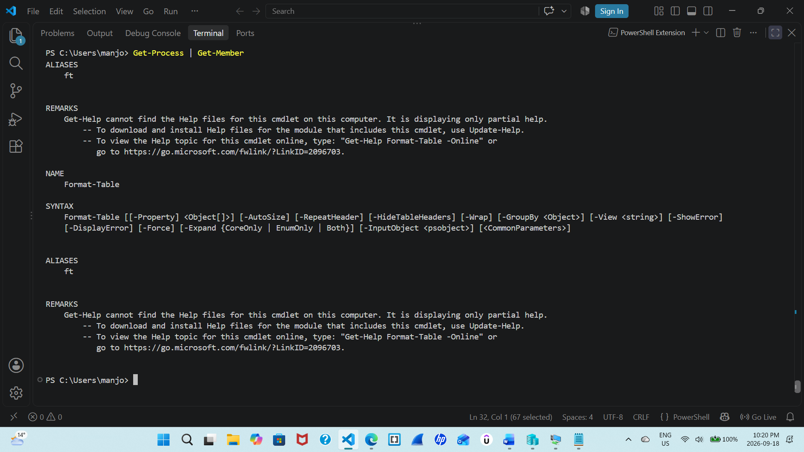Paste the full screenshot here.
This command display help information one page at a time. Commands like help and man are aliases for Get-Help. The Out-Host -Paging command allows the output to be viewed page by page, that makes it easier to read

Step 3 Display more information for a cmdlet
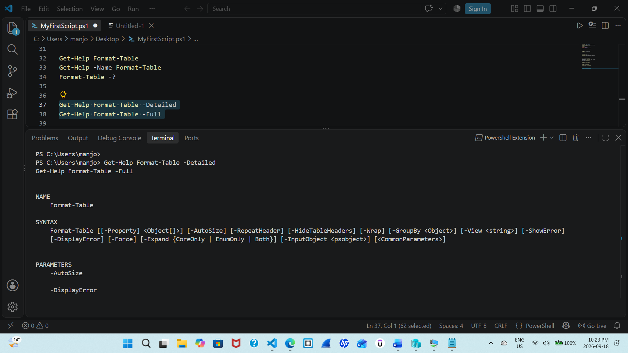 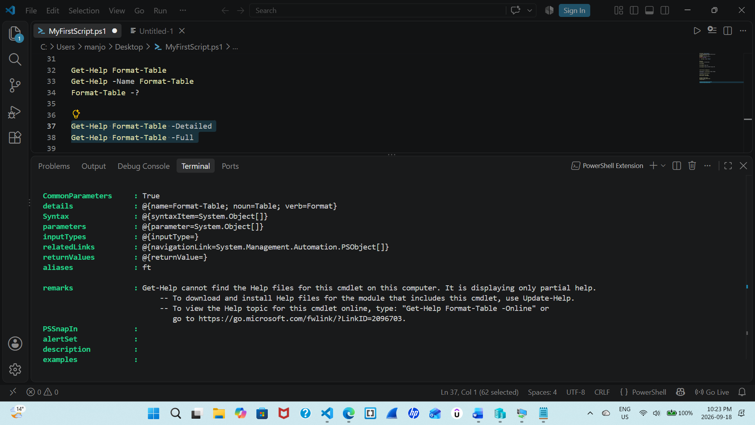 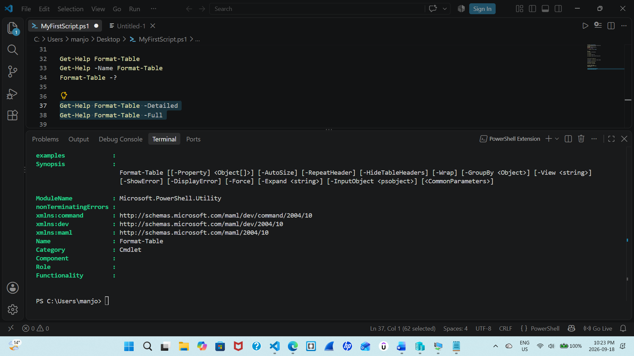Paste the full screenshot here.
The -Detailed parameter displays detailed information about the Format-Table cmdlet than the basic help. The -Full parameter displays the completely available help information, which includes descriptions, parameters, inputs, outputs, and examples.
Step 4 Display selected parts of a cmdlet by using parameters
Get-Help Format-Table -Examples
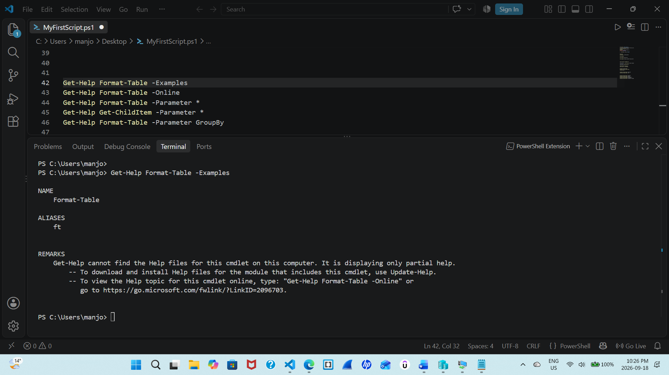

Get-Help Format-Table -Online
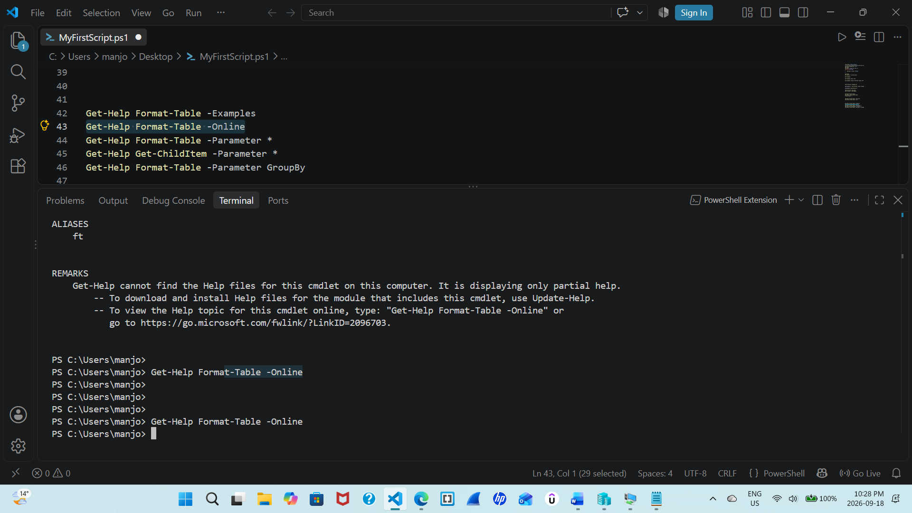
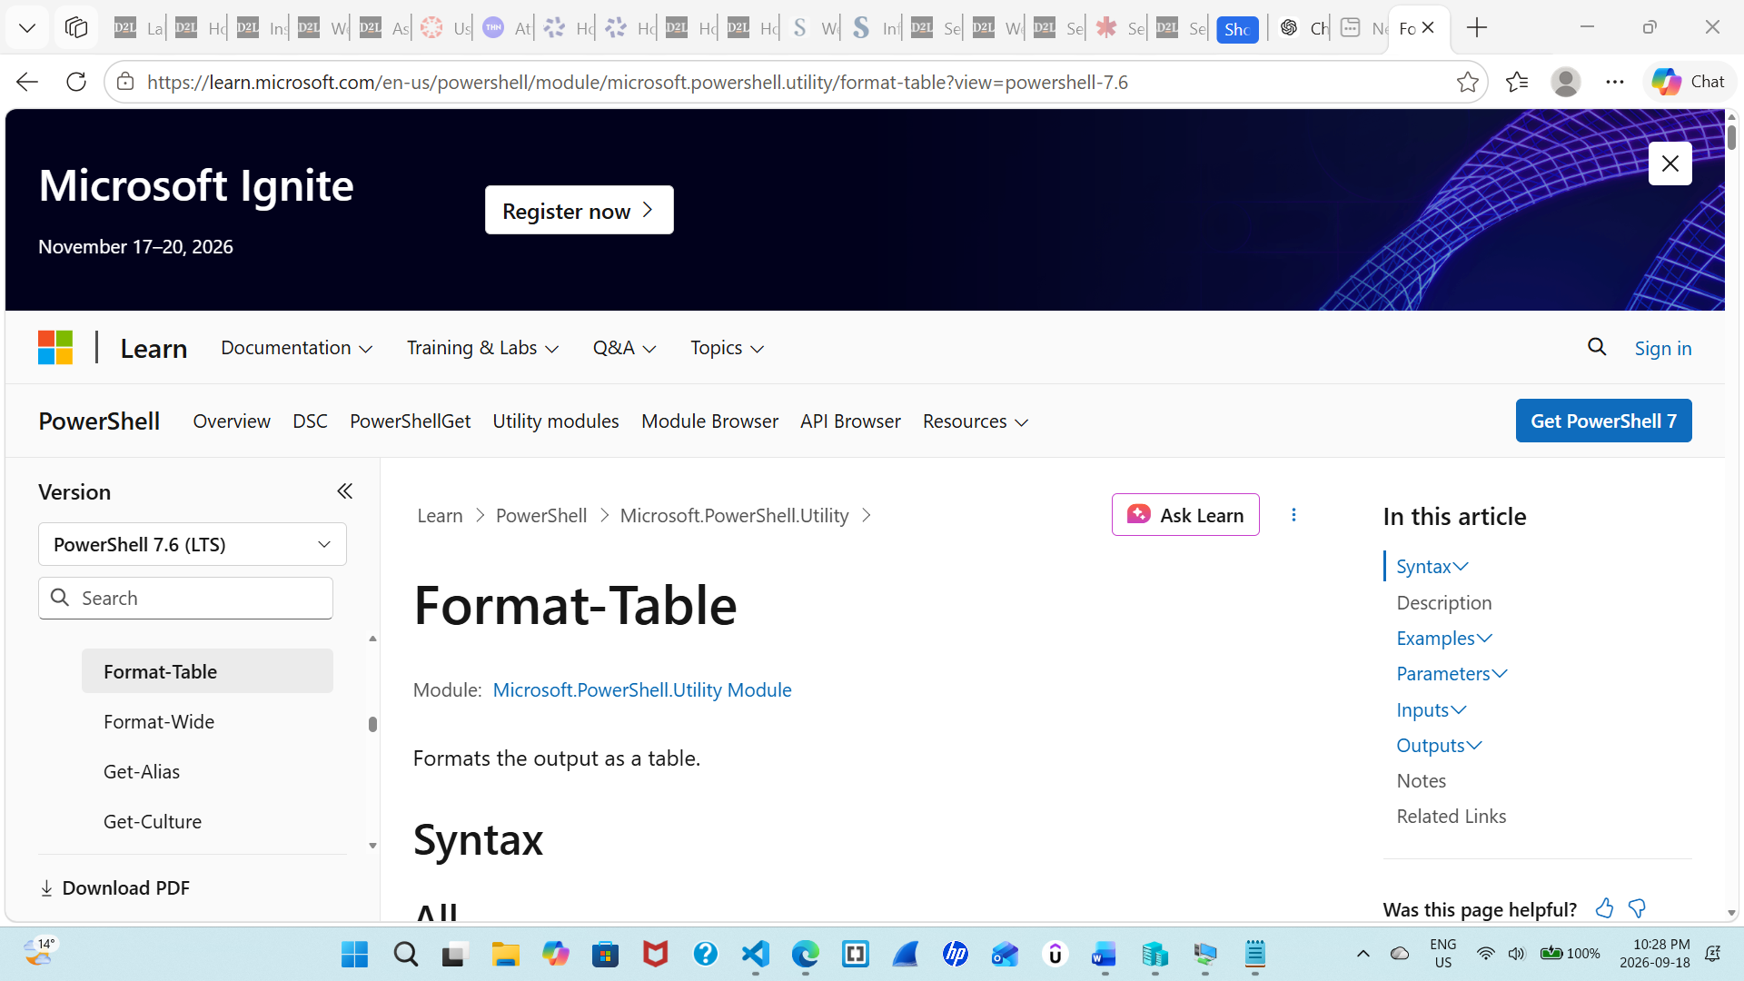

Get-Help Format-Table -Parameter *
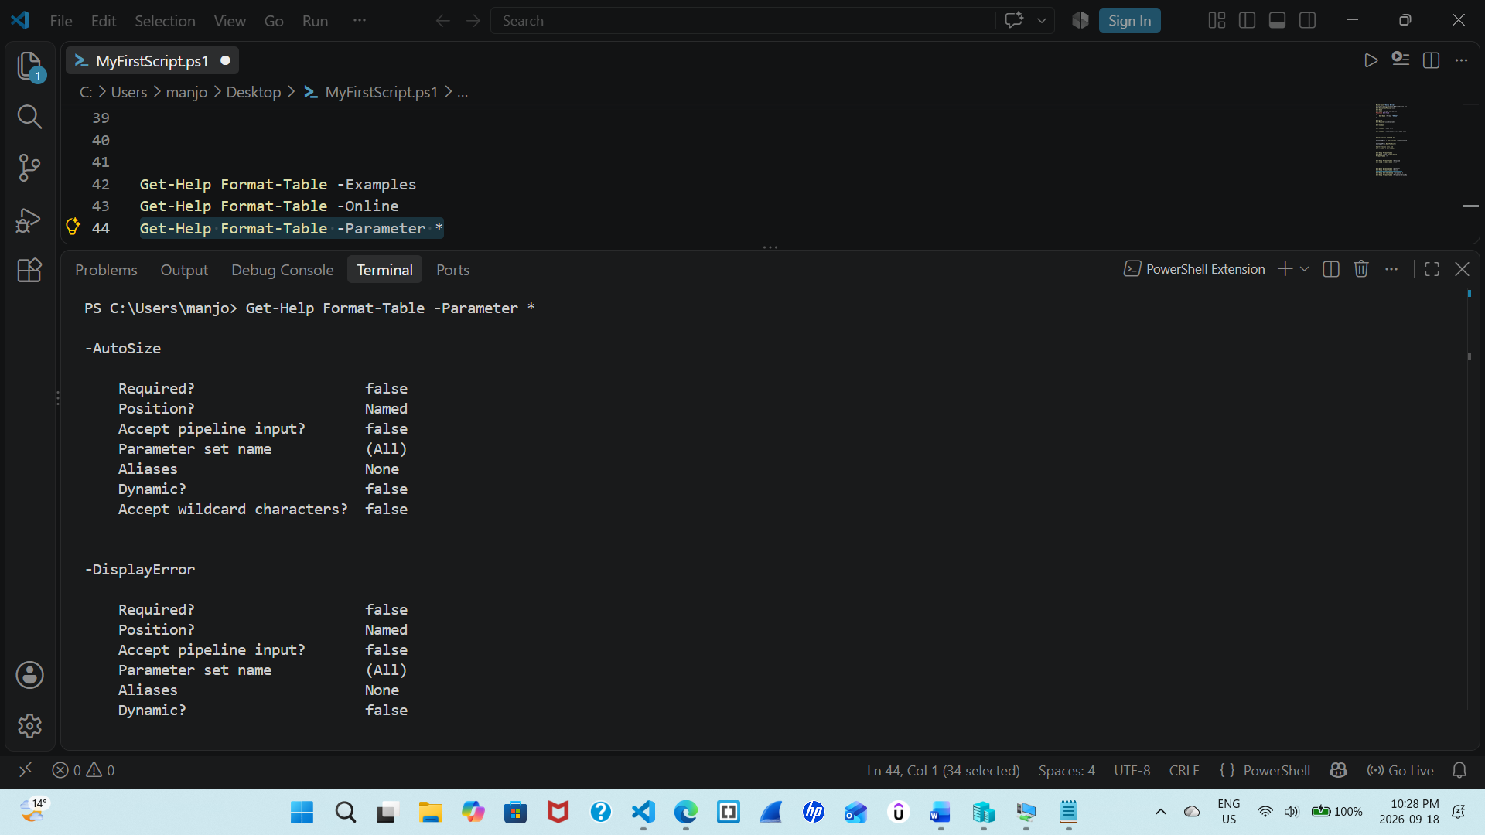
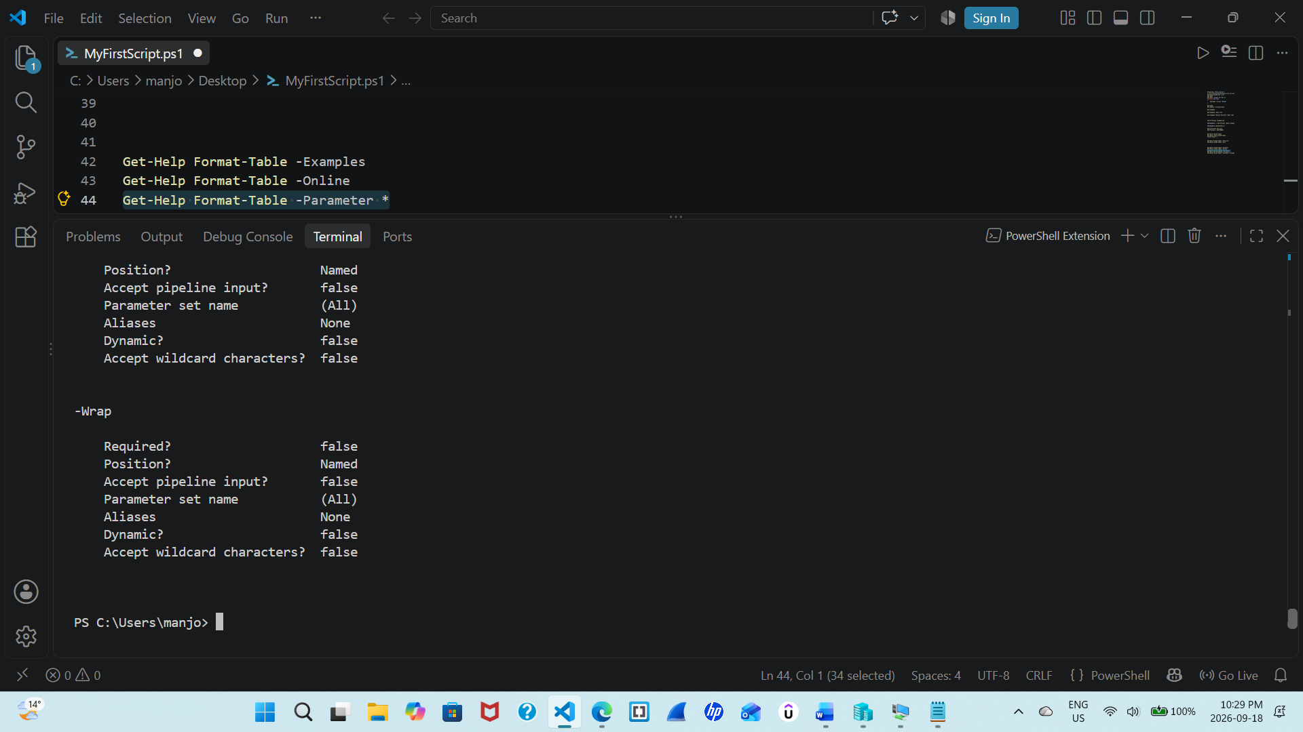

Get-Help Get-ChildItem -Parameter *
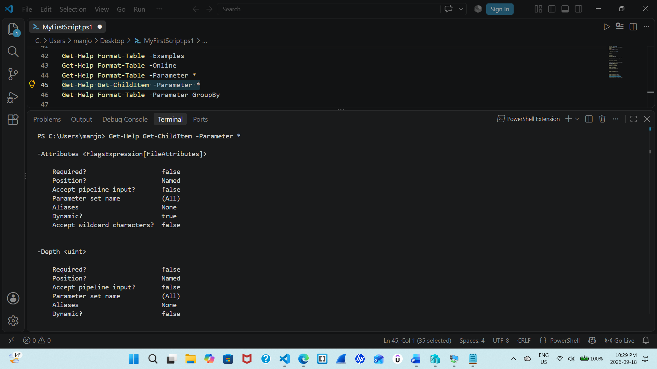
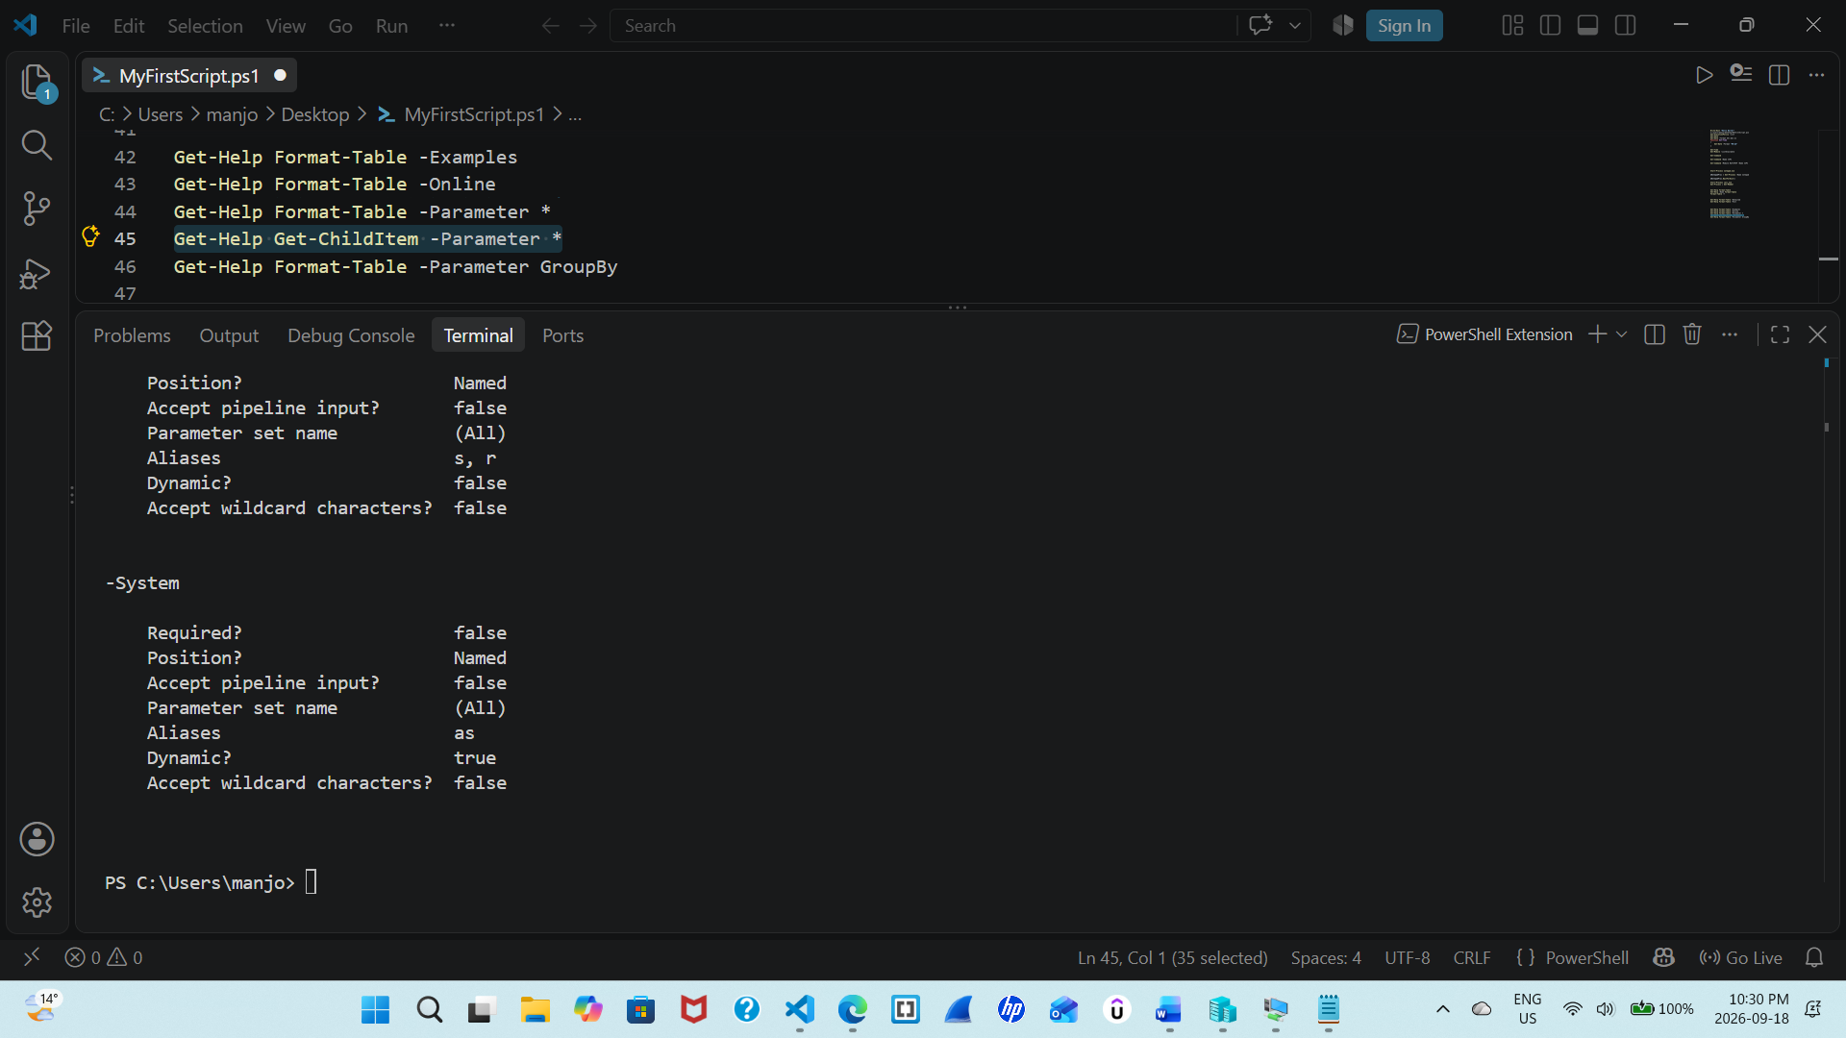

Get-Help Format-Table -Parameter GroupBy
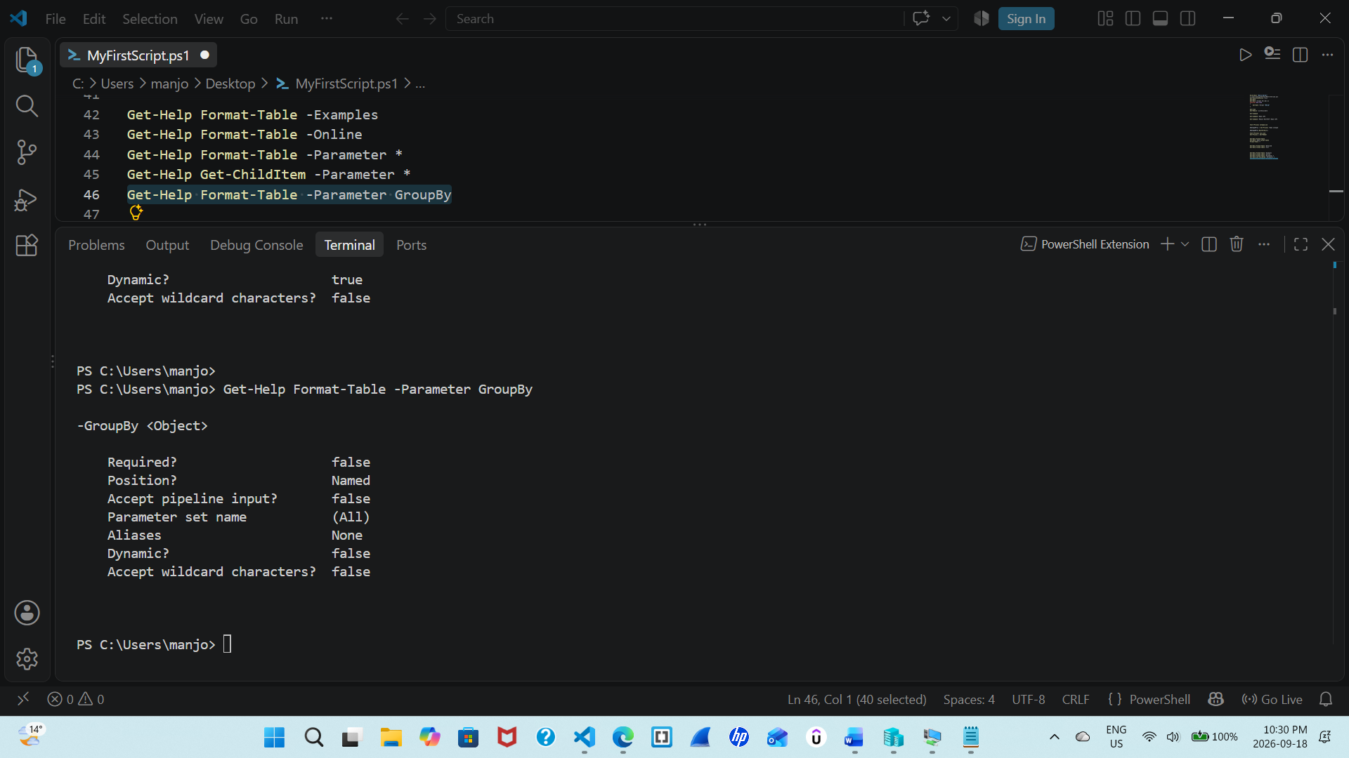

Paste the full screenshot here
These commands display parts of information. -Examples show usage examples, -Online opens the online help page similarly -Parameter * show us information about all parameters. The -Parameter GroupBy command displays help for the GroupBy parameter.

Step 5 Display a list of conceptual articles
Paste the full screenshot here
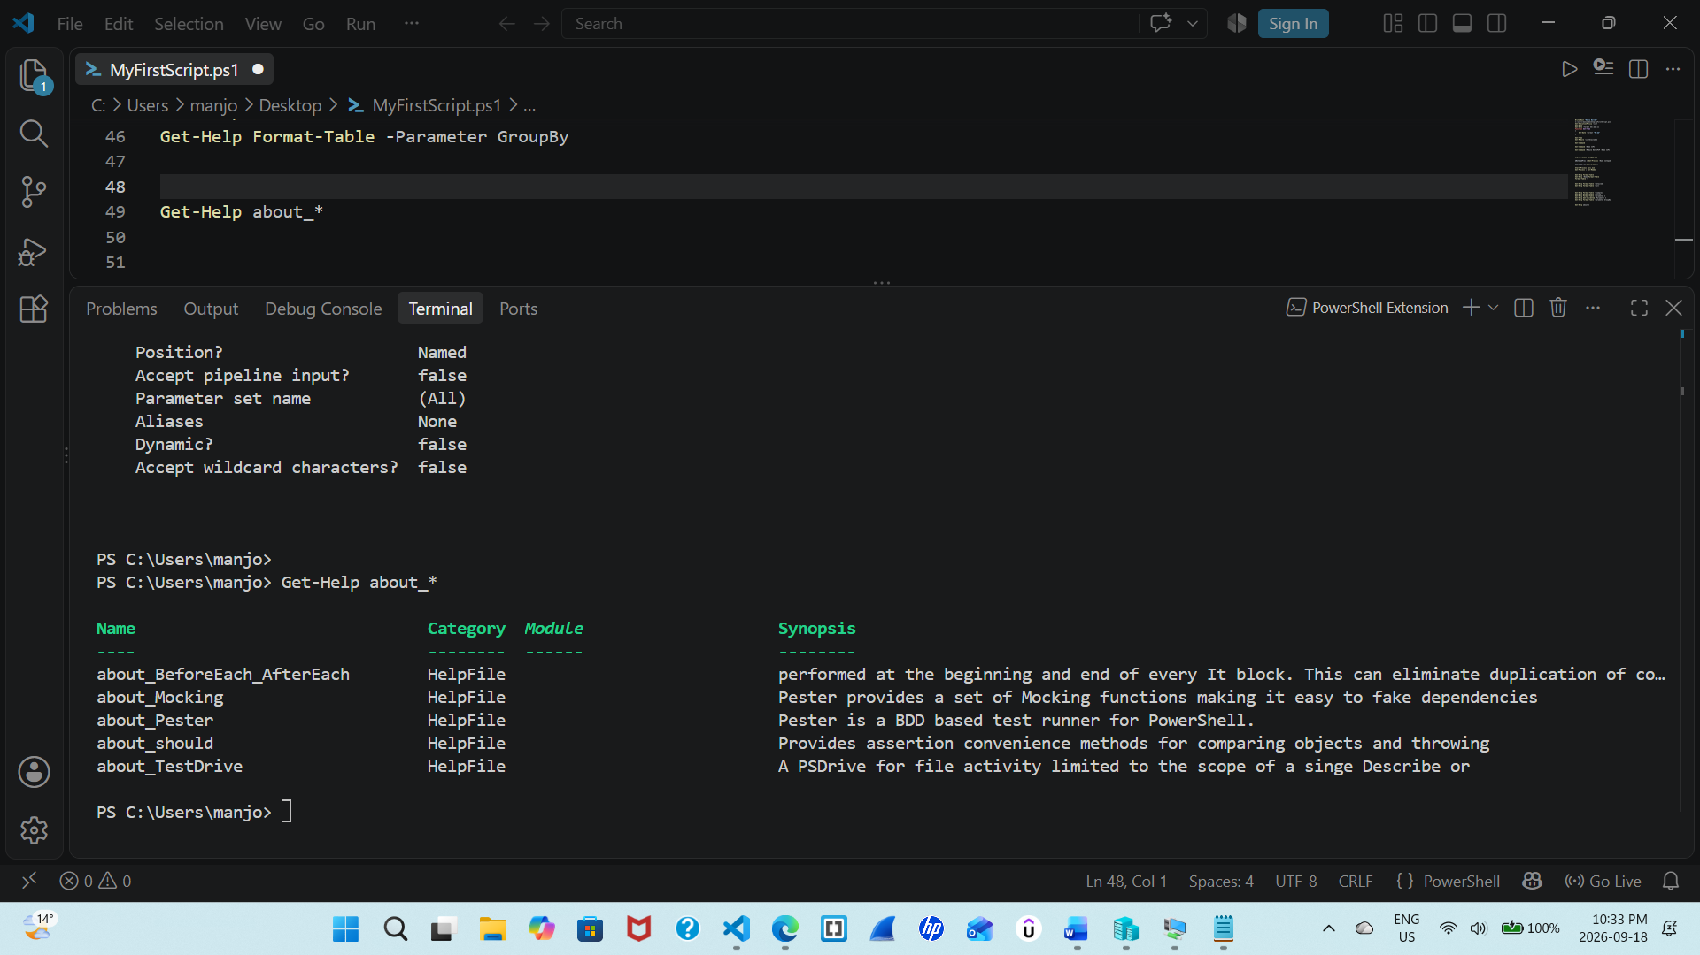
This command just show some concepts that are available in powershell than any specific cmdlet. It just show some general PowerShell concept.

Step 6: Display a list of articles that include a word
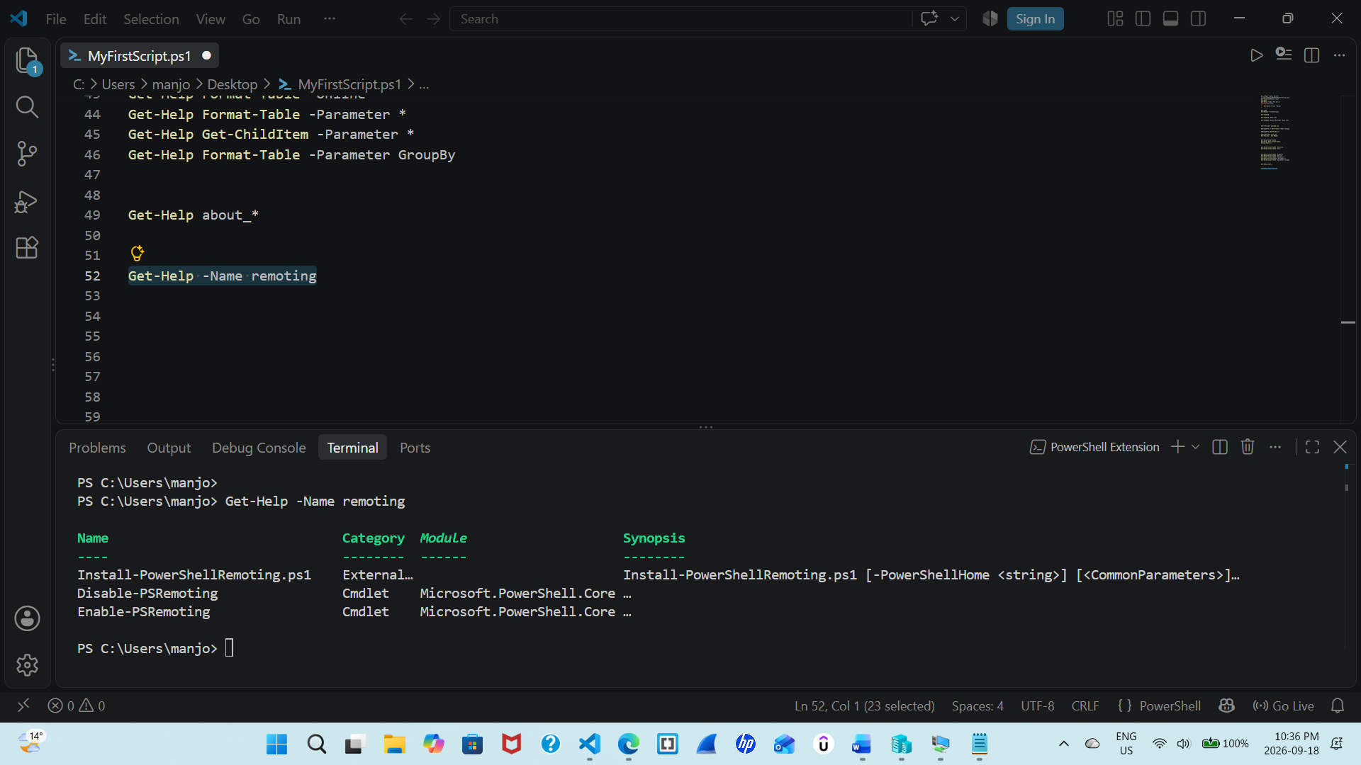
Paste the full screenshot here
It searches for help topic based on power shell remoting and related concepts, commands, or articles available in the currently installed help system.

Step 7: Save the help for specified module
$modulename = ""
$module = Invoke-Command -ComputerName RemoteServer -ScriptBlock { Get-Module -Name $modulename -ListAvailable }
Save-Help -Module $module -DestinationPath "C:\SavedHelp"
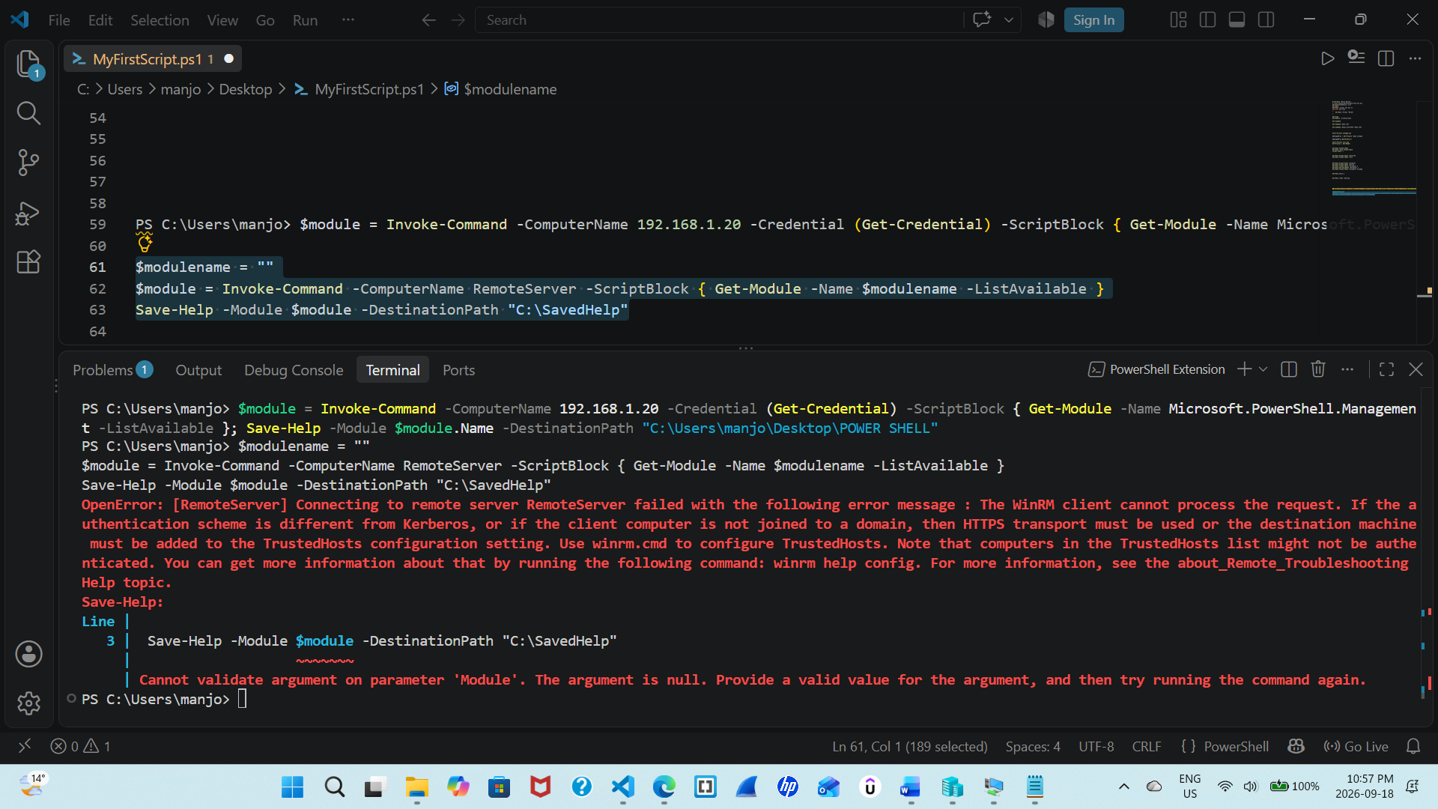
After we put values in this command the following result is achieved. The further are some modifications and observations and result screenshot.

$module = Invoke-Command -ComputerName 192.168.1.20 -Credential (Get-Credential) -ScriptBlock { Get-Module -Name Microsoft.PowerShell.Management -ListAvailable }; Save-Help -Module $module.Name -DestinationPath "C:\Users\manjo\Desktop\POWER SHELL"
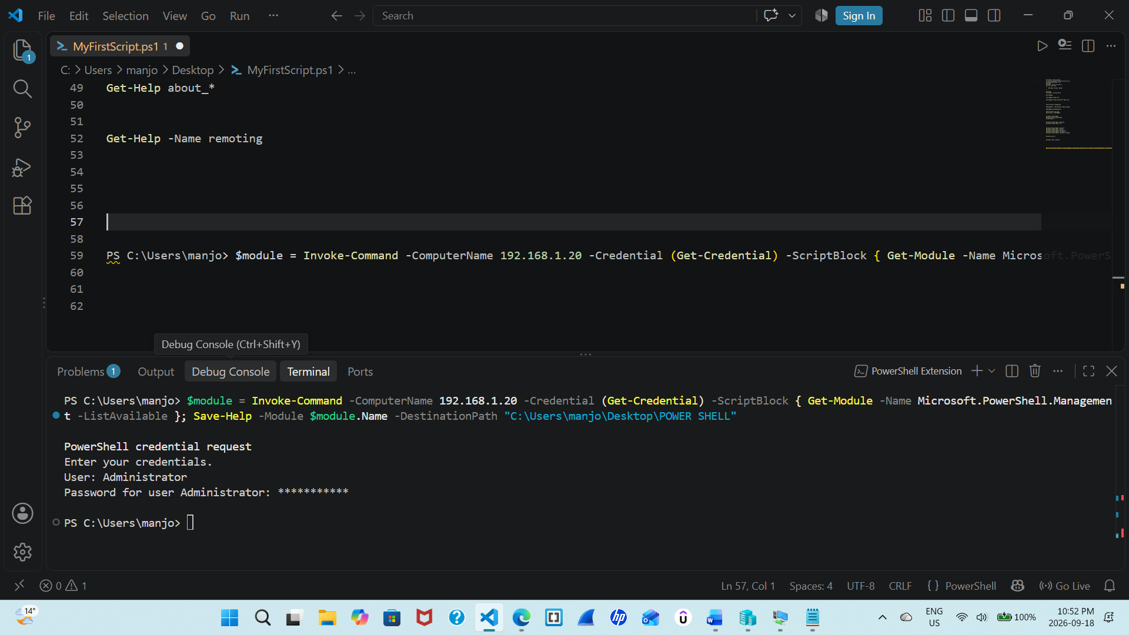
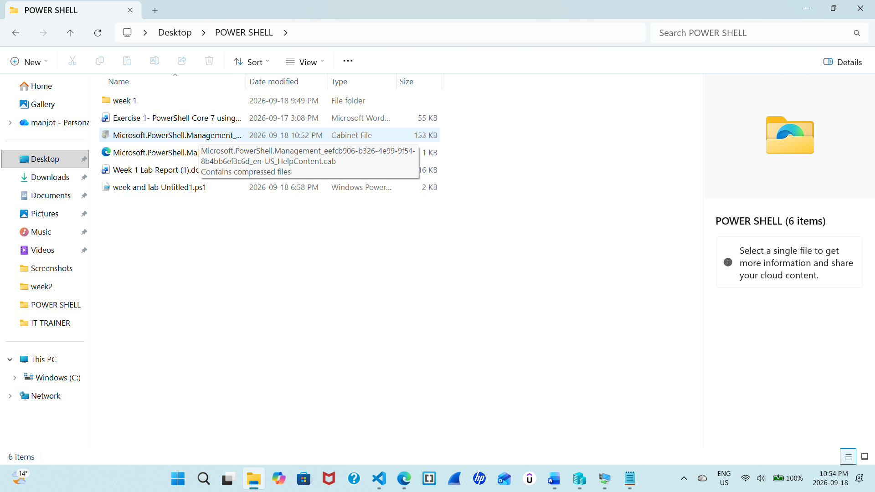
Paste the full screenshot here.

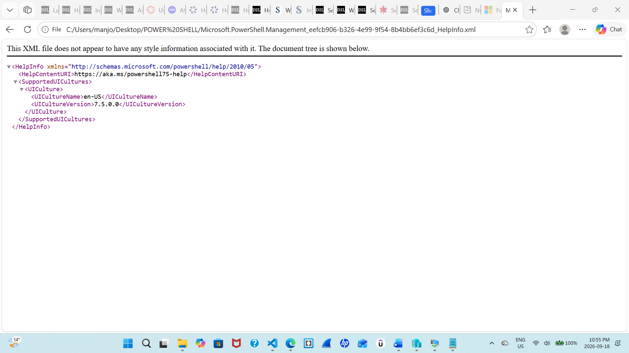

Exercise 3
Follow the steps given in Exercise 3 for PS Remoting
Enable-PSRemoting -Force
Output 1: the remoting function is already working so output is like this
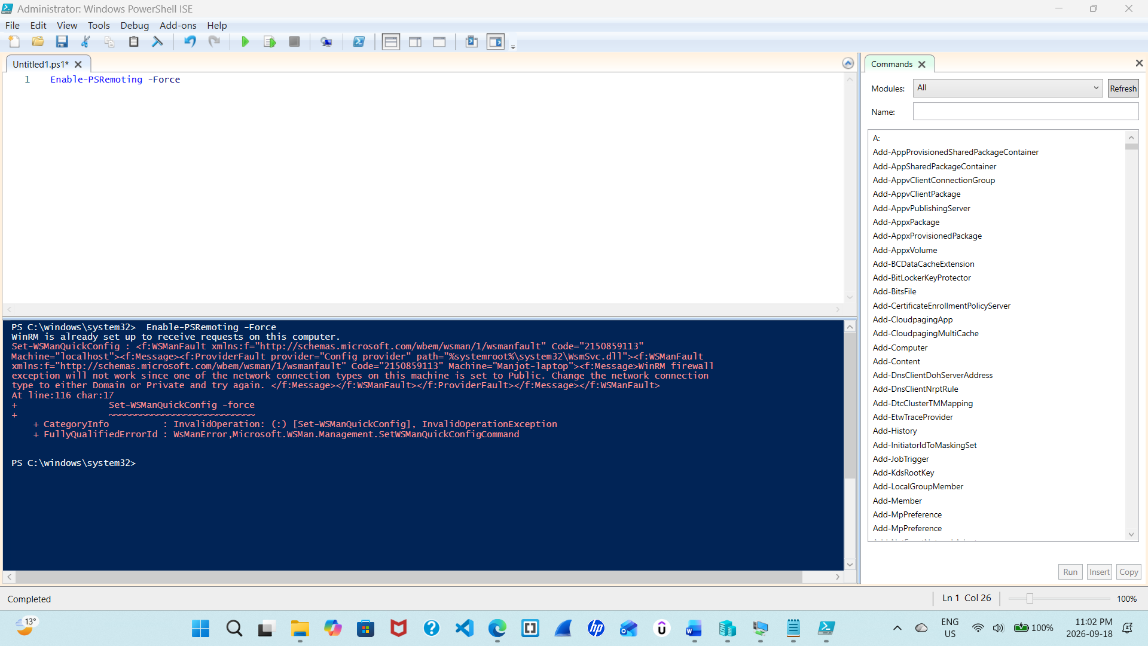
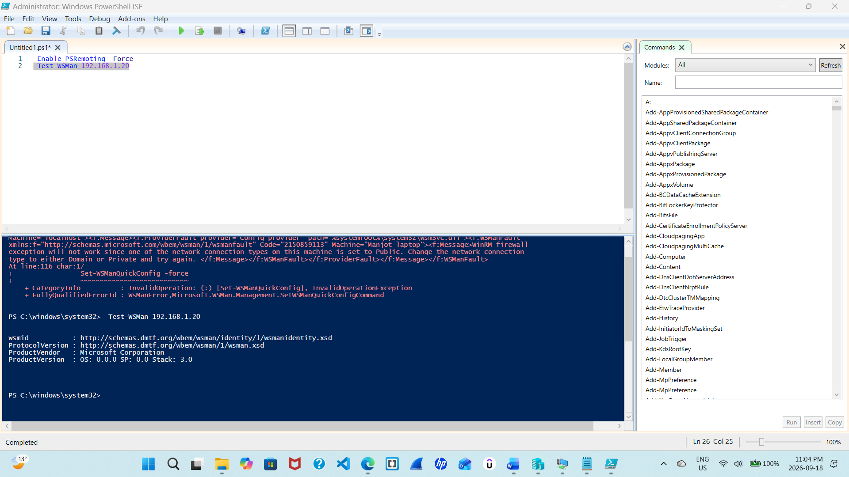 Test-WSMan 192.168.1.20Paste

the full screenshot for Step 5, Testing the PSRemoting,
Output 2:
Invoke-Command -ComputerName 192.168.1.20 -Credential (Get-Credential) -ScriptBlock { Get-ChildItem C:\ }
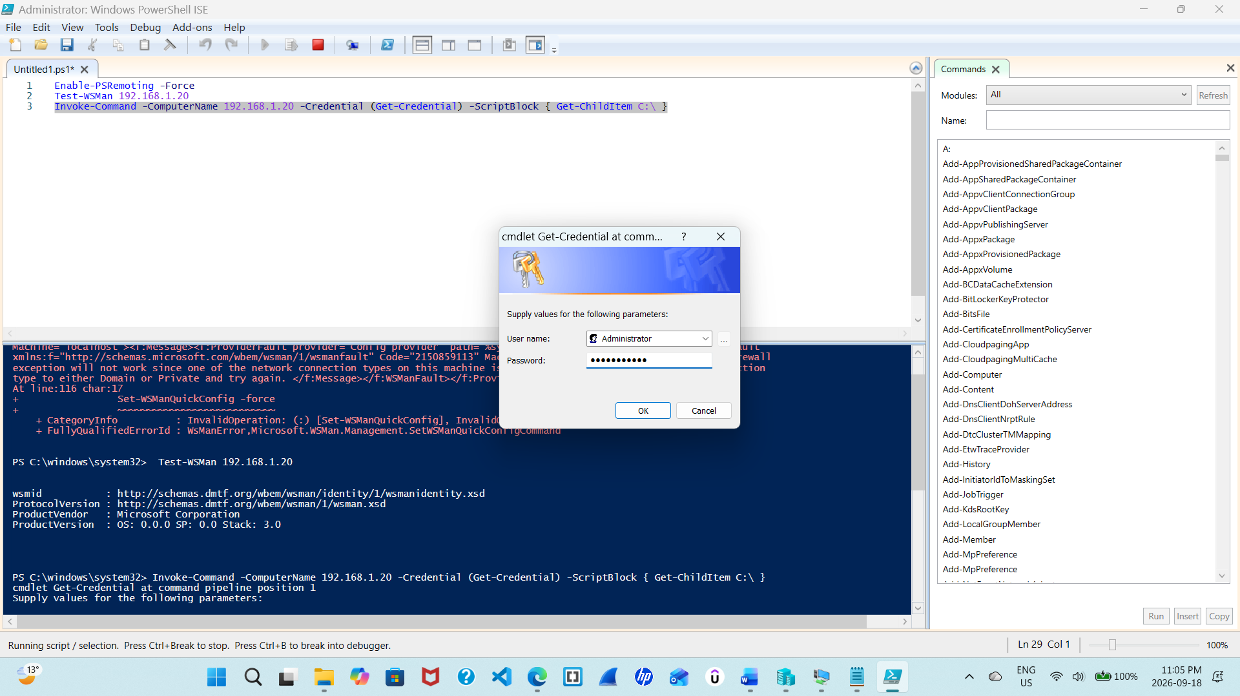
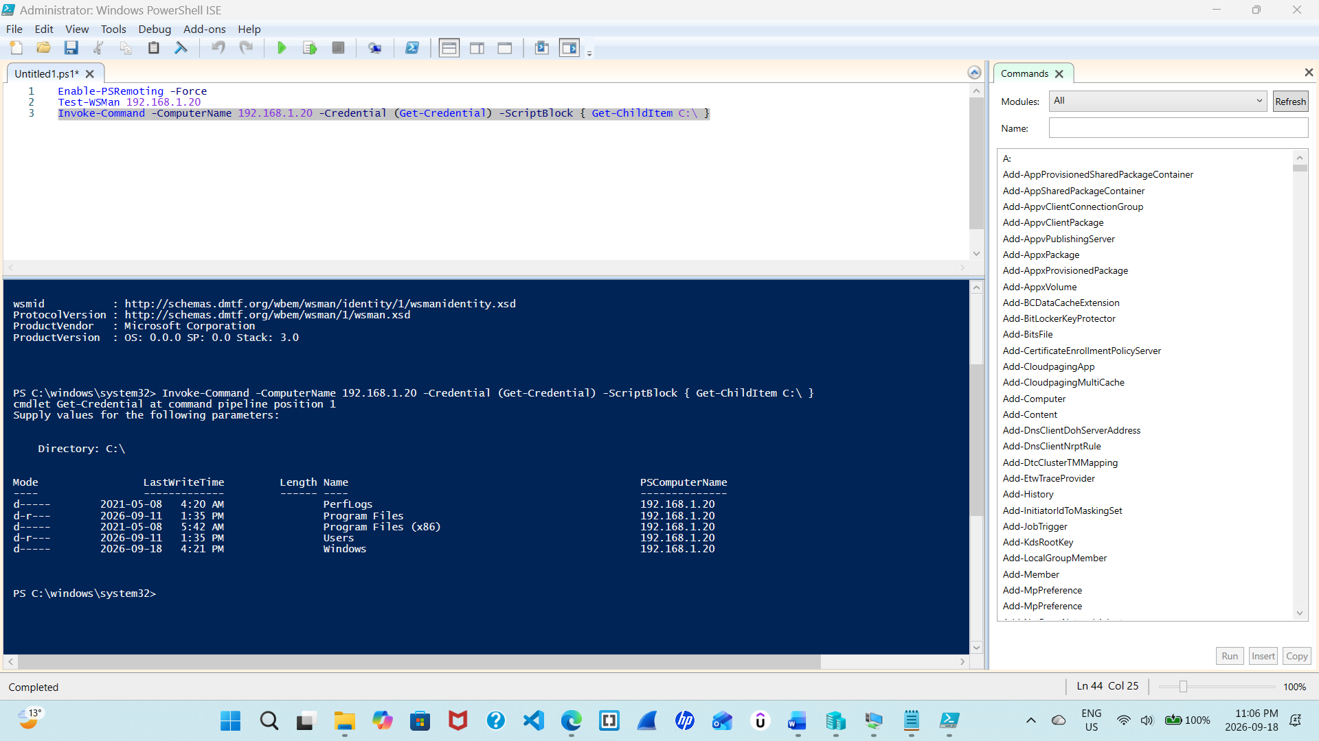Paste the screenshot after executing commands remotely using Invoke-Command.

Output 3: Enter-PSSession -ComputerName 192.168.1.20 -Credential (Get-Credential)
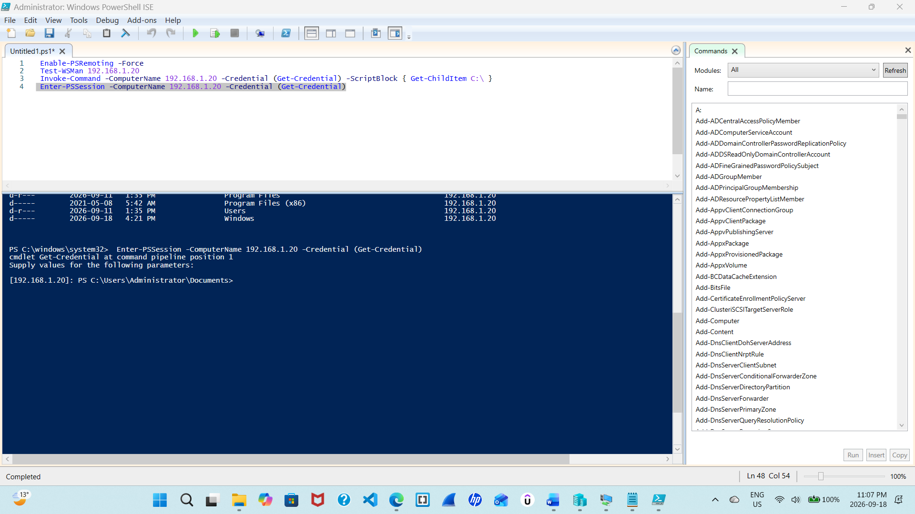Paste the screenshot after establishing an interactive session with Enter-PSSession Command.
function prompt { "Manjot-singh " }

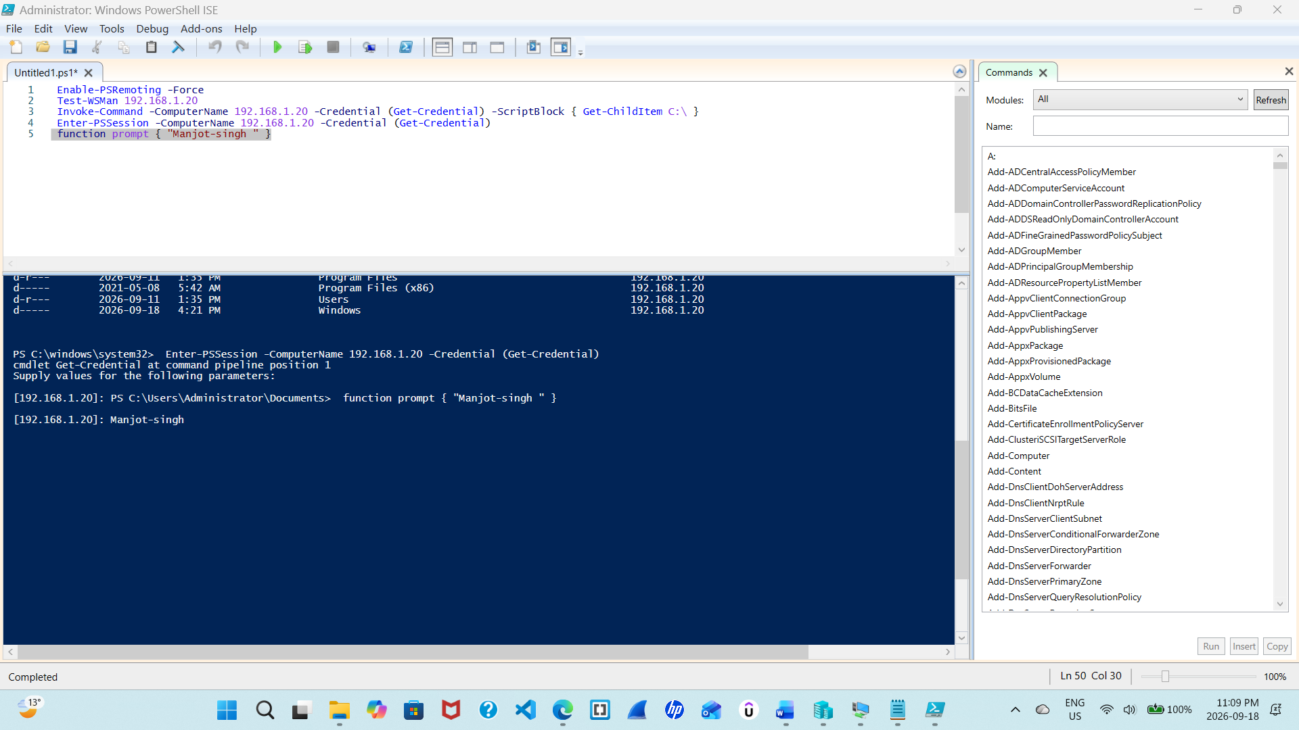

Reflection:
Share your learning in a paragraph of 50-100 words. Share any challenges you faced and how you overcome them.
This lab introduces many different commands like get, invoke, about remote controlling, wsman and so on. Also we learn hoe to connect to server via power shell and use different features using it. We also came to know about the apps we can open and different features like some features like and make our commands easy. Moreover it is a wonderful lab how we can use PowerShell and how we can reach different modules and use it effectively to reach different things from a single interface. I faced some challenges during remote session but those we solved as there was some typing error and some commands details missing.

